**Linux Administration, SHELL SCRIPTING, AWK Programming**

**PRepared by Arun Natarajan**

**==================================================================================================**

**Installation of Linux OS on Windows machine**

**Level 1:**

* Introduction
* Filesystem Hierarchy
* Command Prompt
* Command Syntax, Basic Commands, Help Commands
* File Types
* File and Folder Management
* Vi/Vim Editor
* File Descriptors, Tee
* Word Count
* History
* Filters (grep,cut,sort,tr)
* Process & Memory
* Backup & Restore (tar,zcat,gzip)shell
* Scheduler (at, crontab)
* Find
* Alias

**Level 2:**

* Shell scripting basics
* Variables
* Quotes, Sleep
* Control Statements
* Regular Expressions
* SED
* AWK
* Interactive Scripts
* Script Debugging

Grep

**Installation of Linux OS on Windows machine:**

First we need to install vmware on windows and then linux on vmware.

i.e Windows -> VMware -> Linux

**Installation of VMware tool 10.0 on Windows 7/8/10**

**Pre requisite:**

Your windows machine should statisfy below criteria:

Minimum of 4GB RAM and i3 processor……. more than that will be recommended.

Virtualization should be in "Enabled" status on your desktop/laptop BIOS settings, as per below image.

Note: As per system brand(HP, IBM, VAIO…) BIOS settings will differ, you need to check for the same as per your machine to enable “Virtualization” technology.

**-**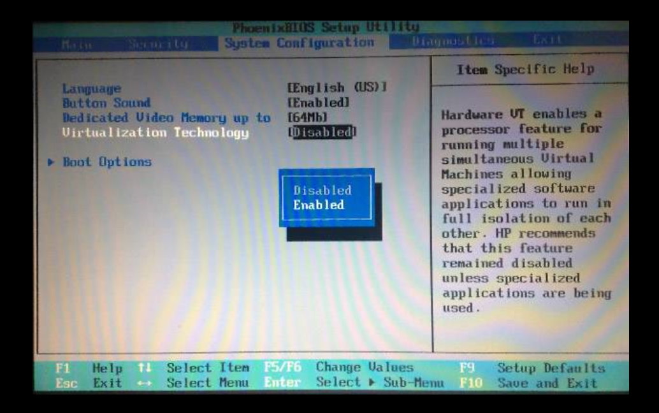

**Step 1**

Now, we are going to install VMware 10.0 on Windows 10 machine.

You can download the setup file from my G-Drive or from google.

Software:

https://drive.google.com/open?id=0B1usxOmTVpWUfkVyVklmazhDemtqQ25VbUJWdG80U0NBU3FHREQyMVRCeVVubFJ5eVNuS1E

I ll be using below VMware setup file for installation.

Now, double click on VMware 10.0 setup file to initialize the installation.

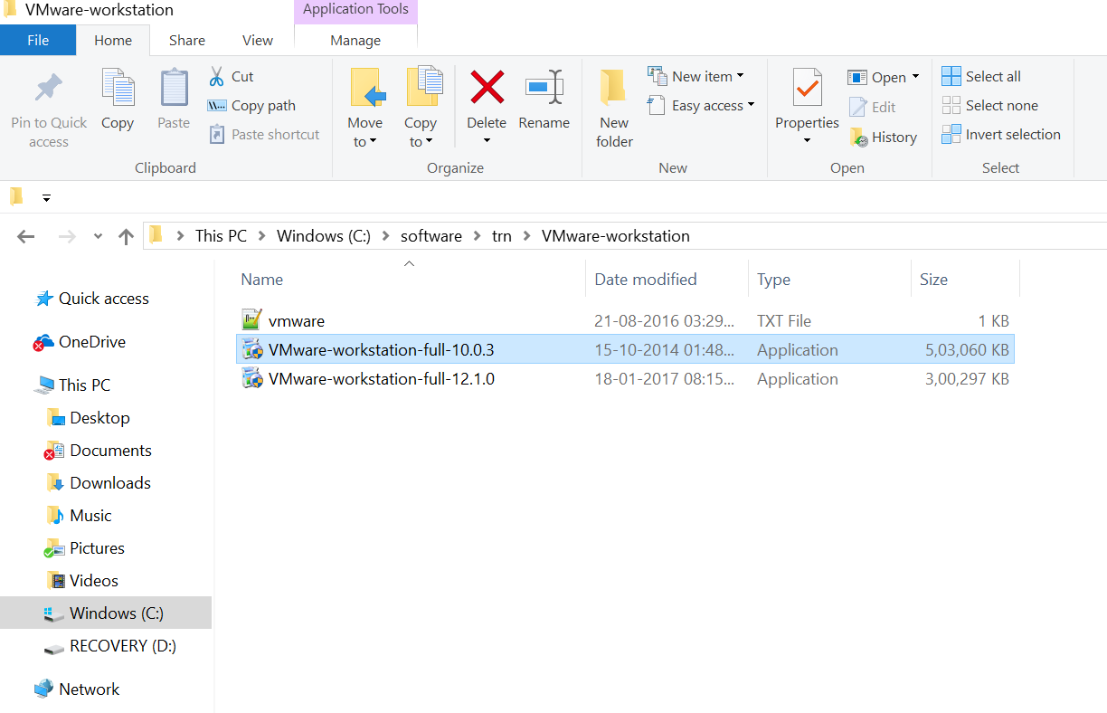

**Step 2 :**

Once you got VMware setup screen, click on NEXT.

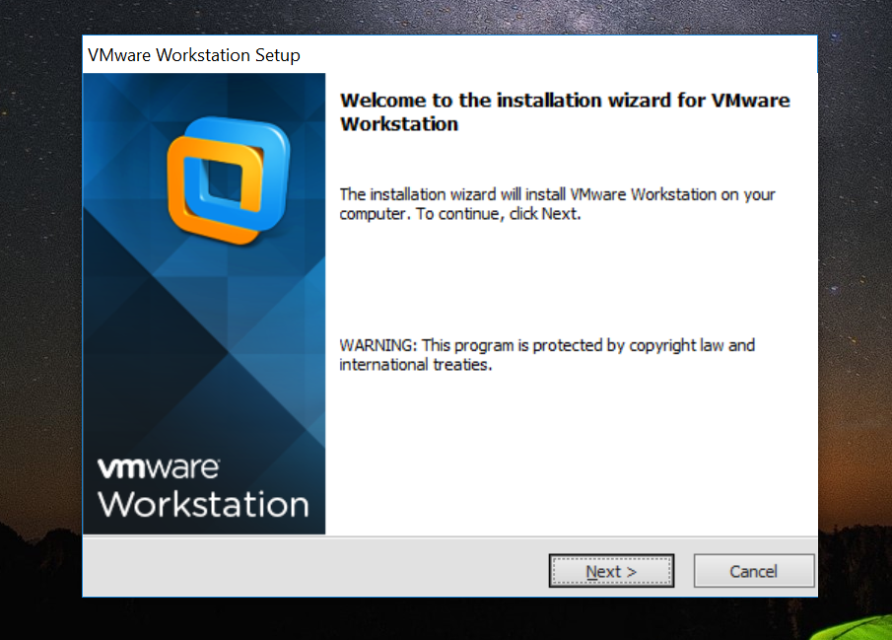

**Step 3:**

Agree with the license agreement and click on NEXT.

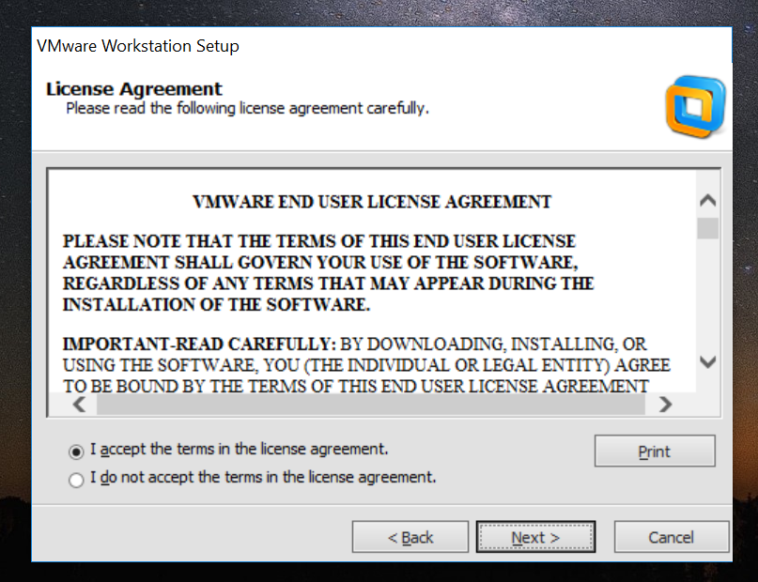

**Step 4:**

Select Typical installation and click on NEXT

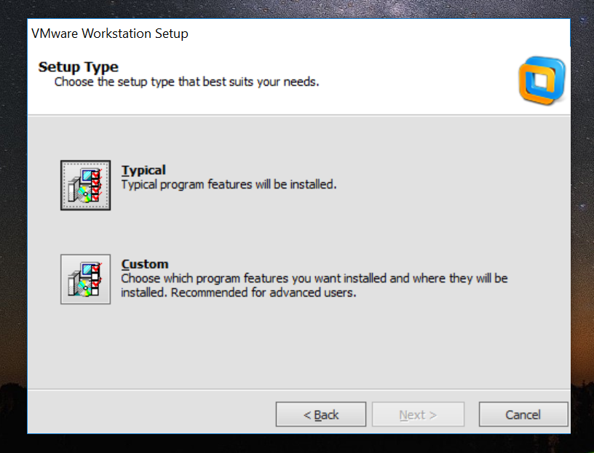

**Step 5 :**

Choose your installation folder, by default it will be installed on C: drive.

You can change the installation where ever you have the space on your windows machine.

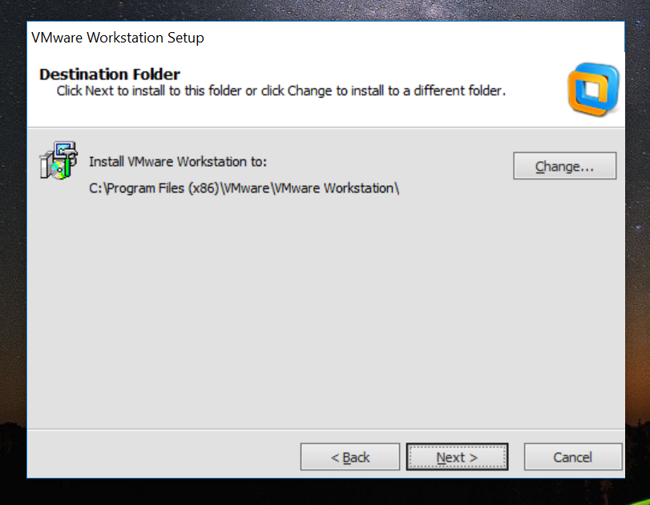

**Step 6:**

Enter the key information as per below from the provided key file from my G-Drive.

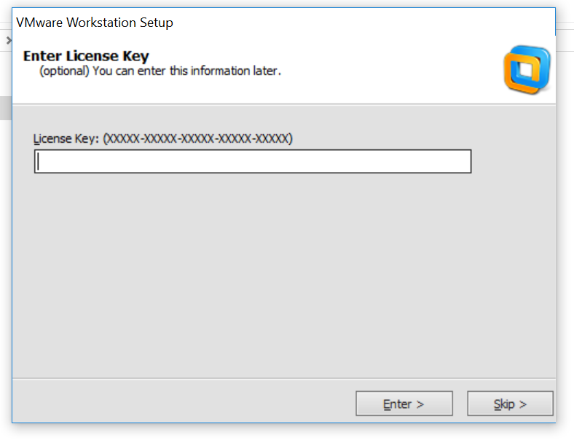

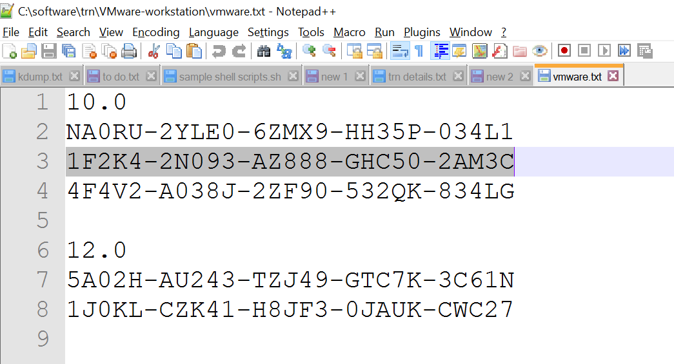

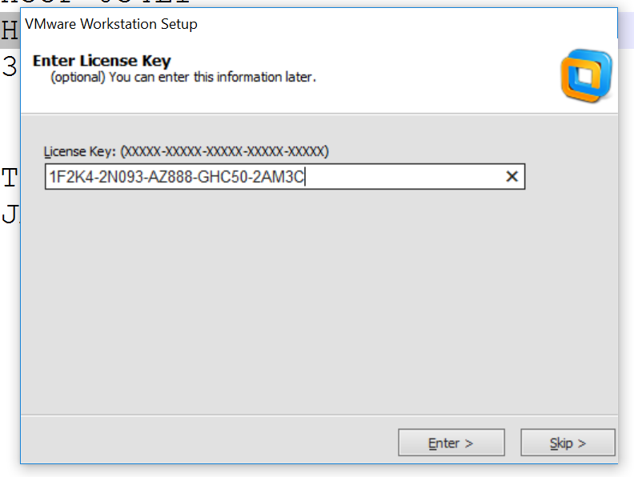

**Step 7:**

Keep proceeding with NEXT button for few more screens and at last click on Continue

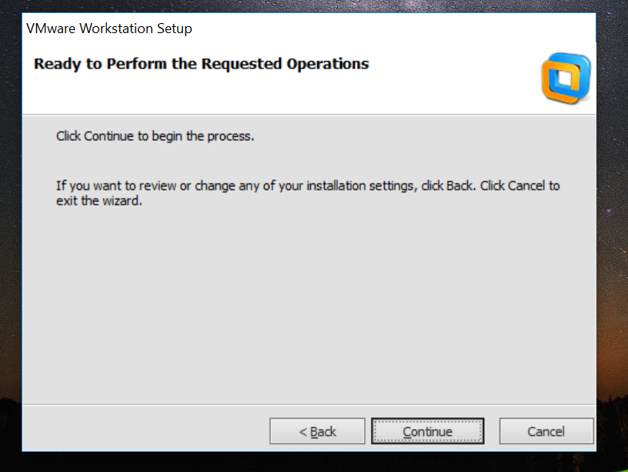

**Step 8:**

After clicking on Continue, your VMWare installation will start.

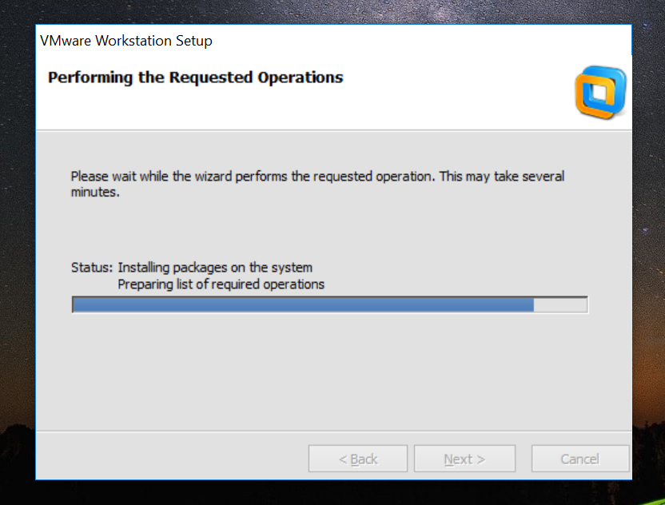

**Step 9:**

After VMware installation is done, click on *Finish.* Now you can able to see VMware icon on your desktop

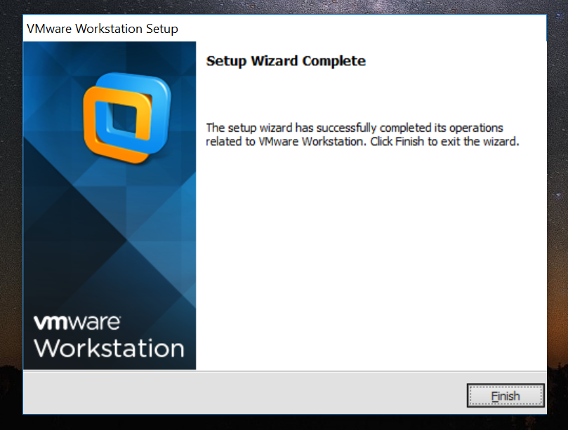

**Step 10:**

Please verify the same below screenshot.



Now, we are done with installation VMware tool on windows machine.

**Installation of RHEL 6.0 on VMware tool.**

Make sure you have RHEL 6.0 iso file ready with you before starting the installation.

You can download it from my G-Drive or Google.

Software:

<https://drive.google.com/open?id=0B1usxOmTVpWUfkVyVklmazhDemtqQ25VbUJWdG80U0NBU3FHREQyMVRCeVVubFJ5eVNuS1E>

Below highlighted file will be used for installation now.

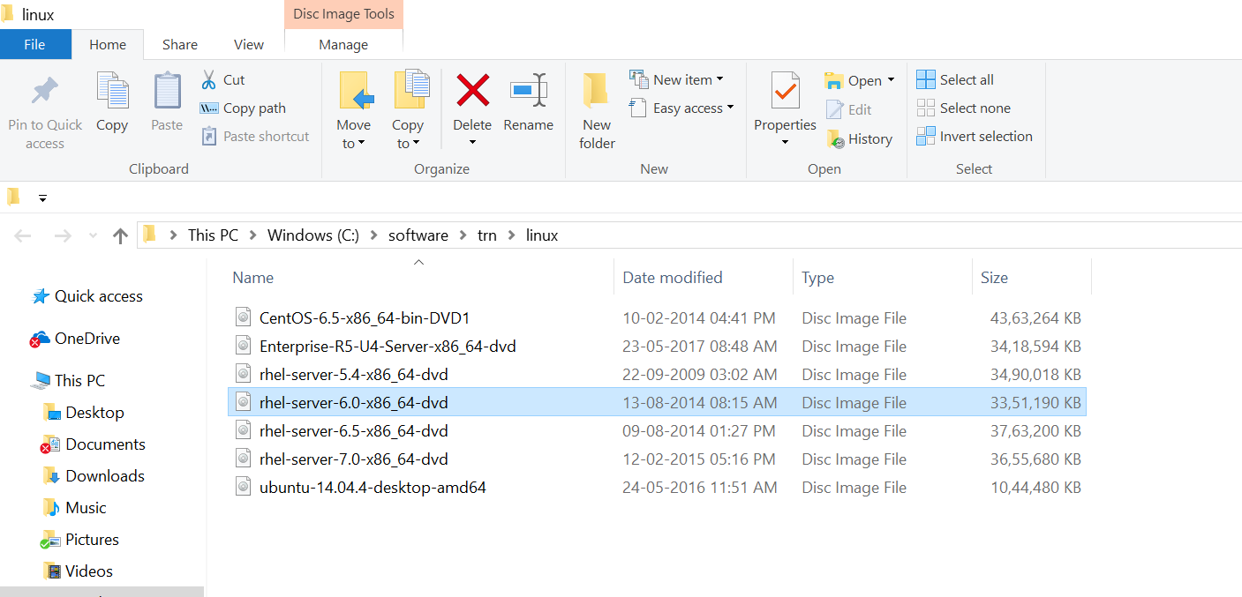

**Step 1:**

Click on VMware icon available on your Desktop, so that you will be getting the below screen.

Once VMware application is opened, click “Create a New Virtual Machine” .

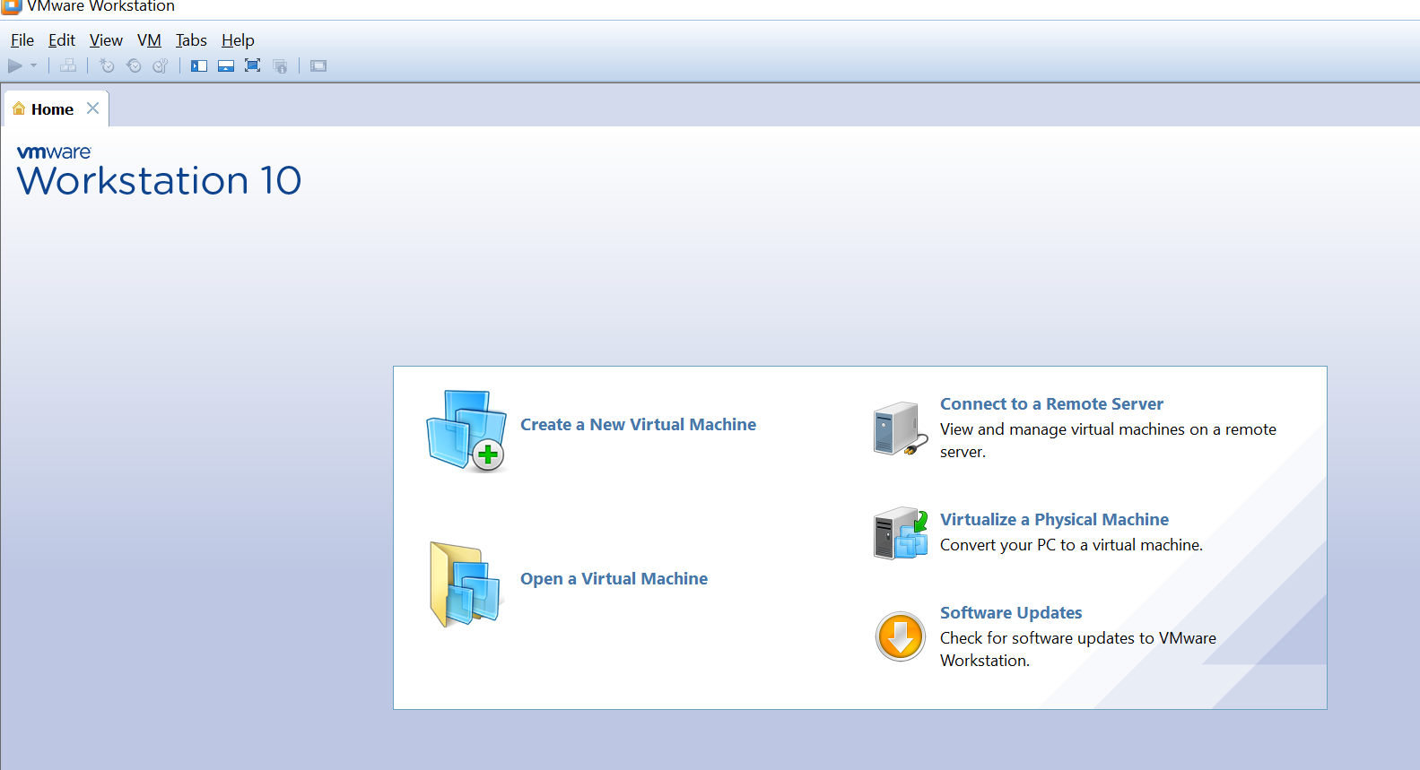

**Step 2:**

Select Typical installation on click on *NEXT*

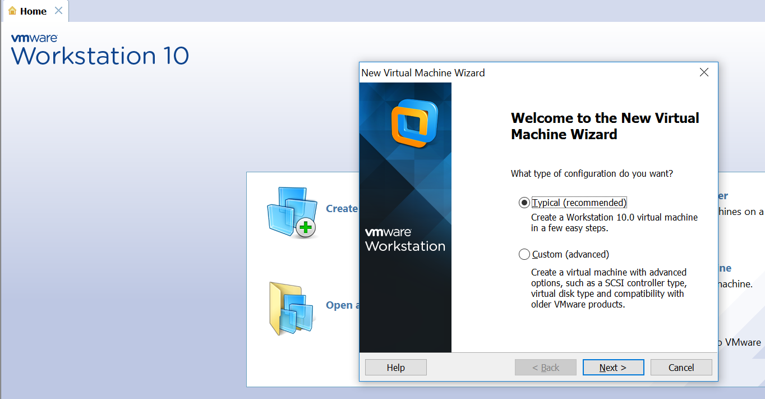

**Step 3:**

Select ISO option and click browse to map your RHEL 6.0 iso file from your windows machine and click on *NEXT*

I have the RHEL 6.0 iso file at *c:\software\trn\linux\rhel-server-6.0-x86_64-dvd.iso*

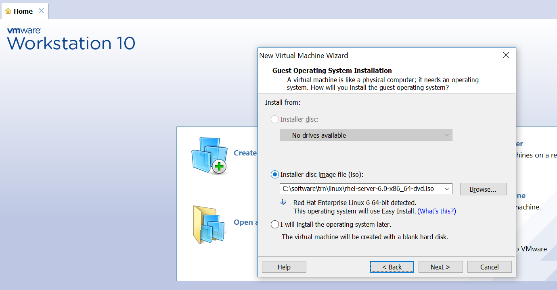

**Step 4:**

Now its time to create normal user and its password. Create the same with below credentials.

Full name: user1

User name: user1

Password: redhat

Confirm: redhat

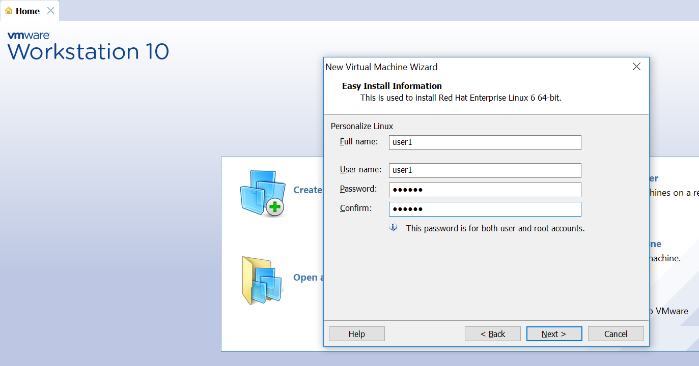

**Step 5:**

Choose your installation folder, by default it will be installed on C: drive.

You can change the installation destination where ever you have the space(20GB) on your windows machine.

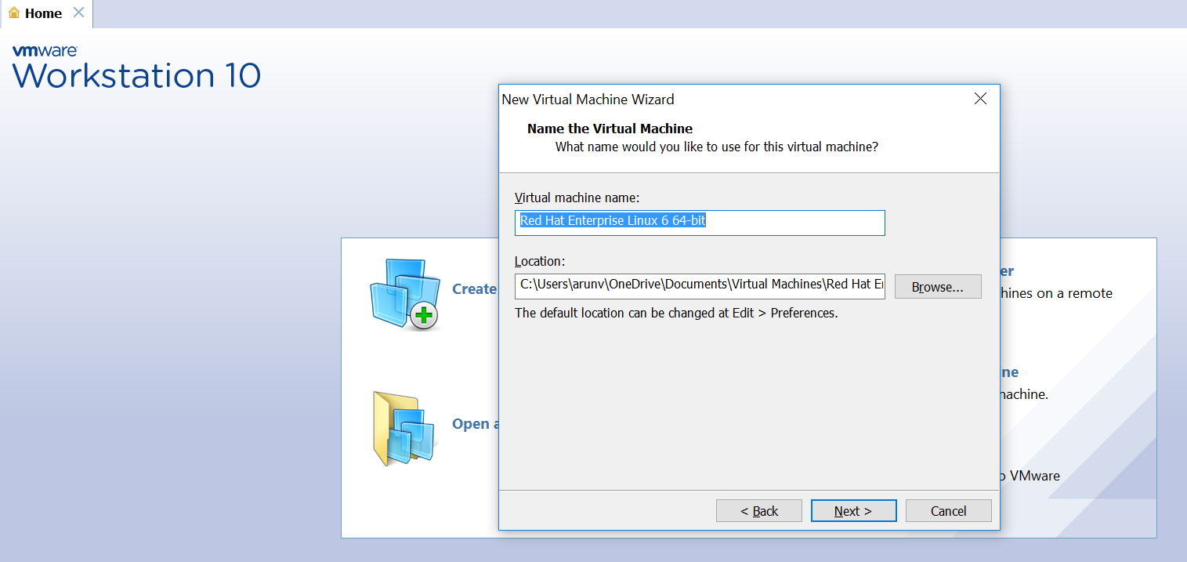

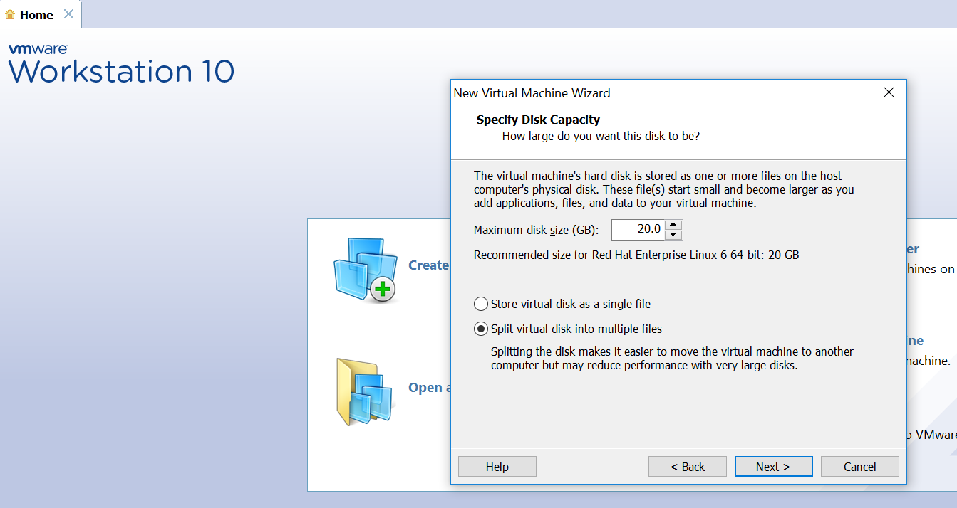

**Step 6:**

You can now summarize your installation parameter, before starting with installation process.

You can also increase your VMware image(RHEL 6.0) RAM size by clicking on *“Customize Hardware”*, if required.

Click on *Finish* now.

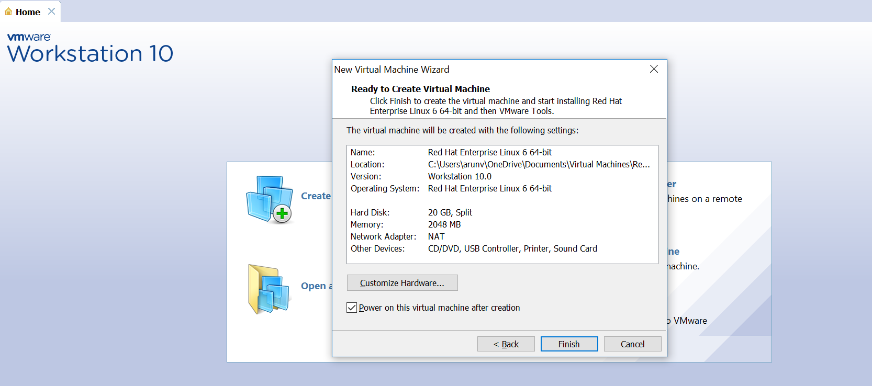

**Step 7:**

Now installation will start automatically as like below screen shots.

It ll will not ask for any information, because its an easy installation with pre-configured setup.

It ll restart the Virtual image (RHEL 6.0) automatically and will end up in asking *username* and *password.*

*Provide below credentials by clicking on other:*

Username: root

Password: redhat

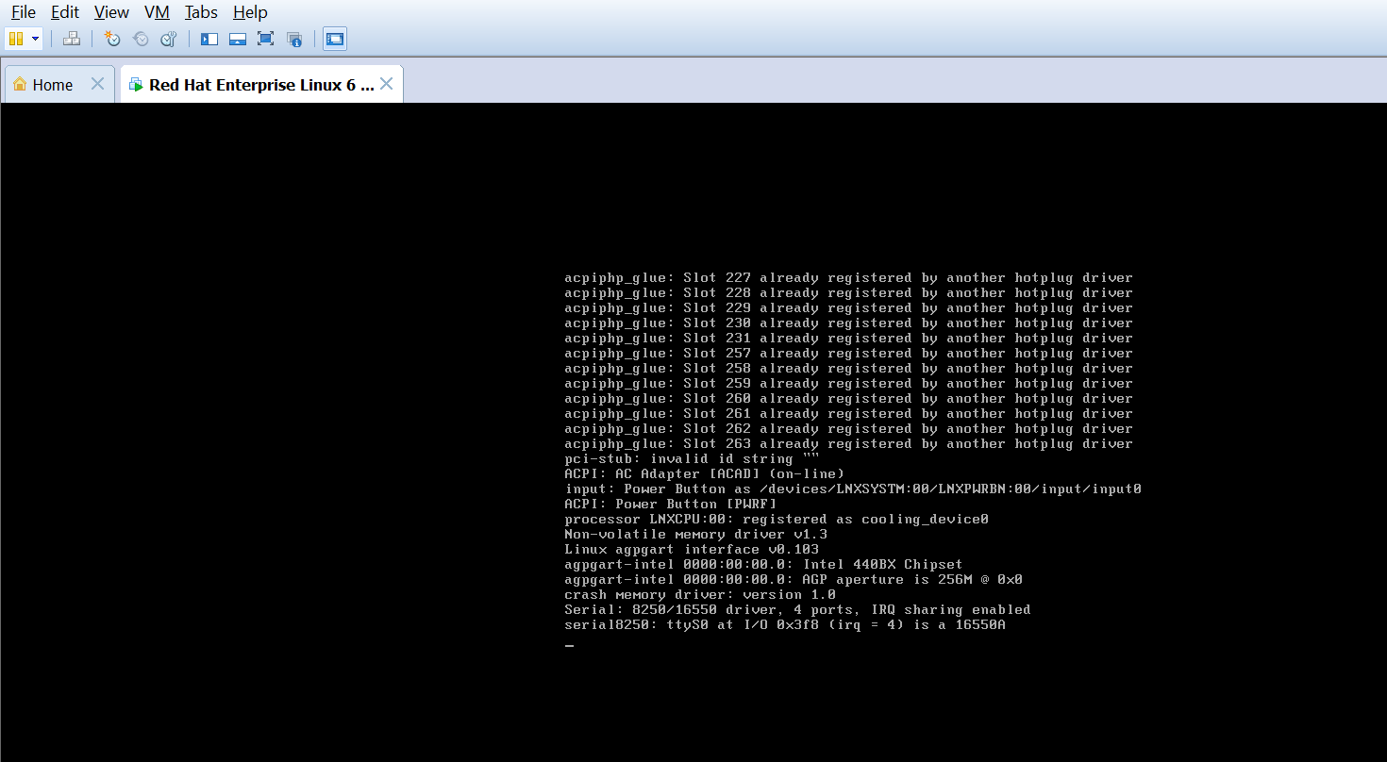

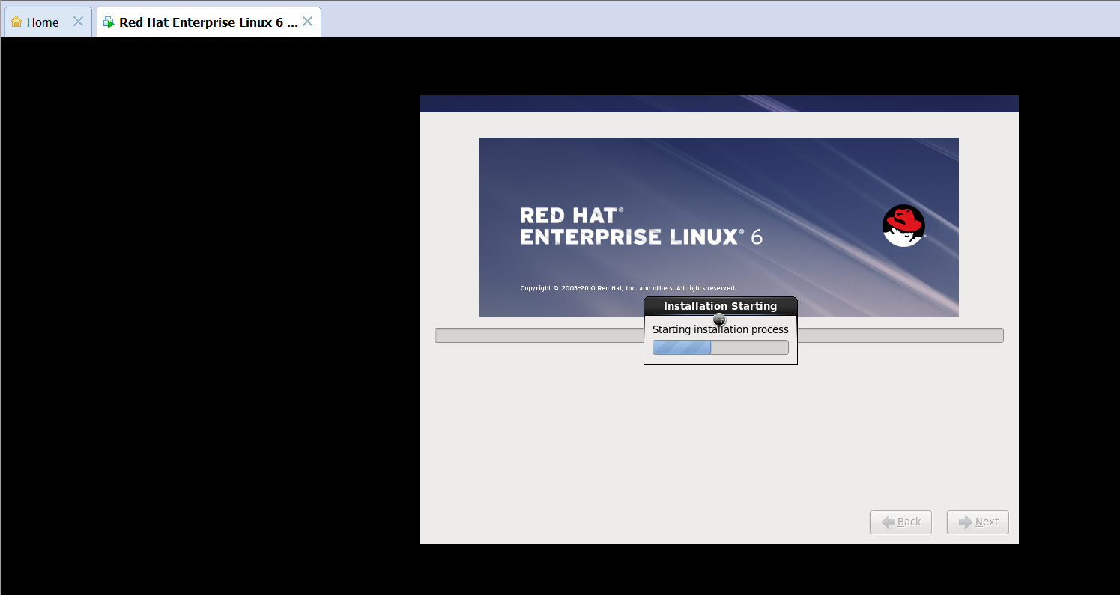

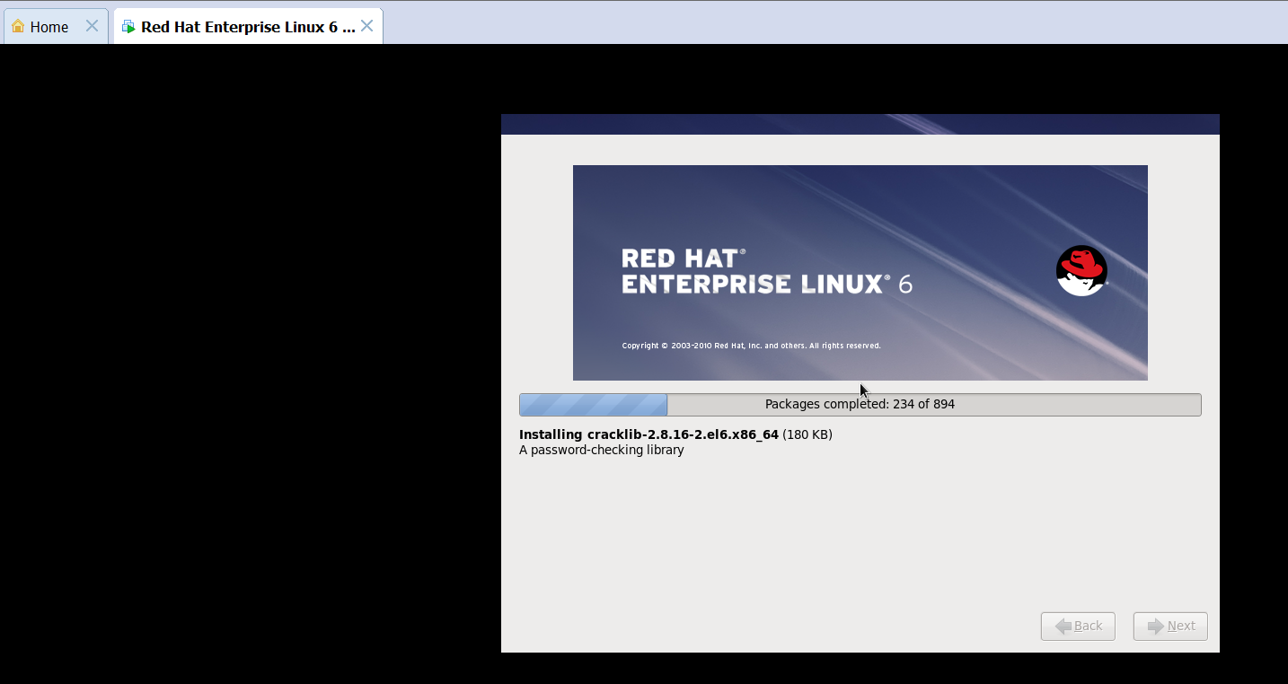

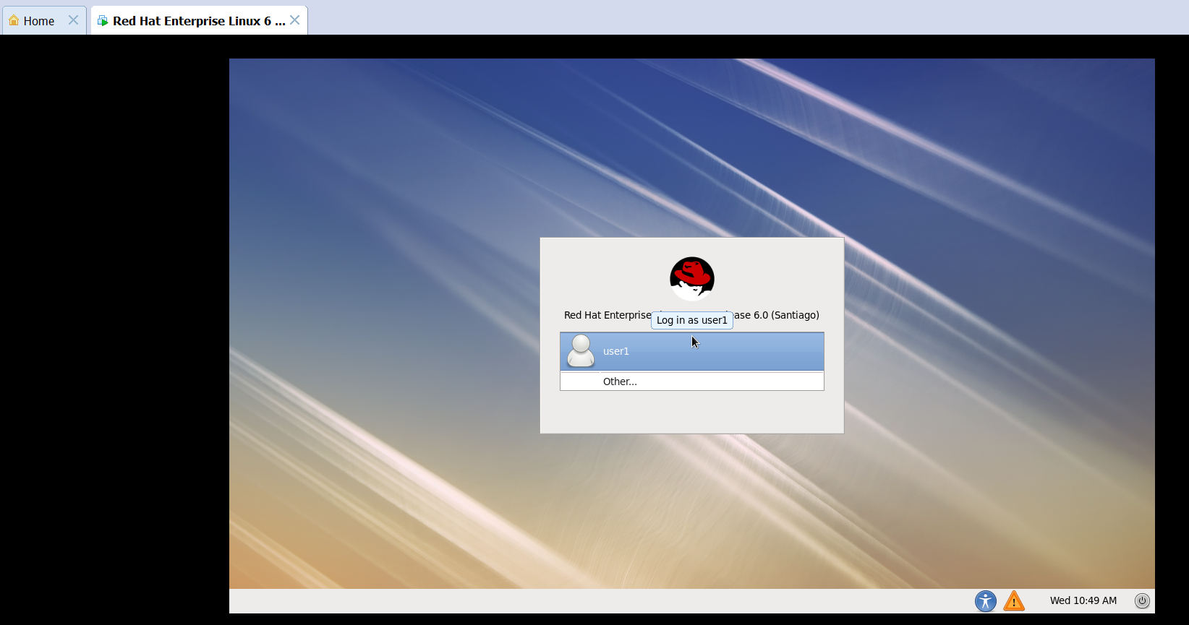

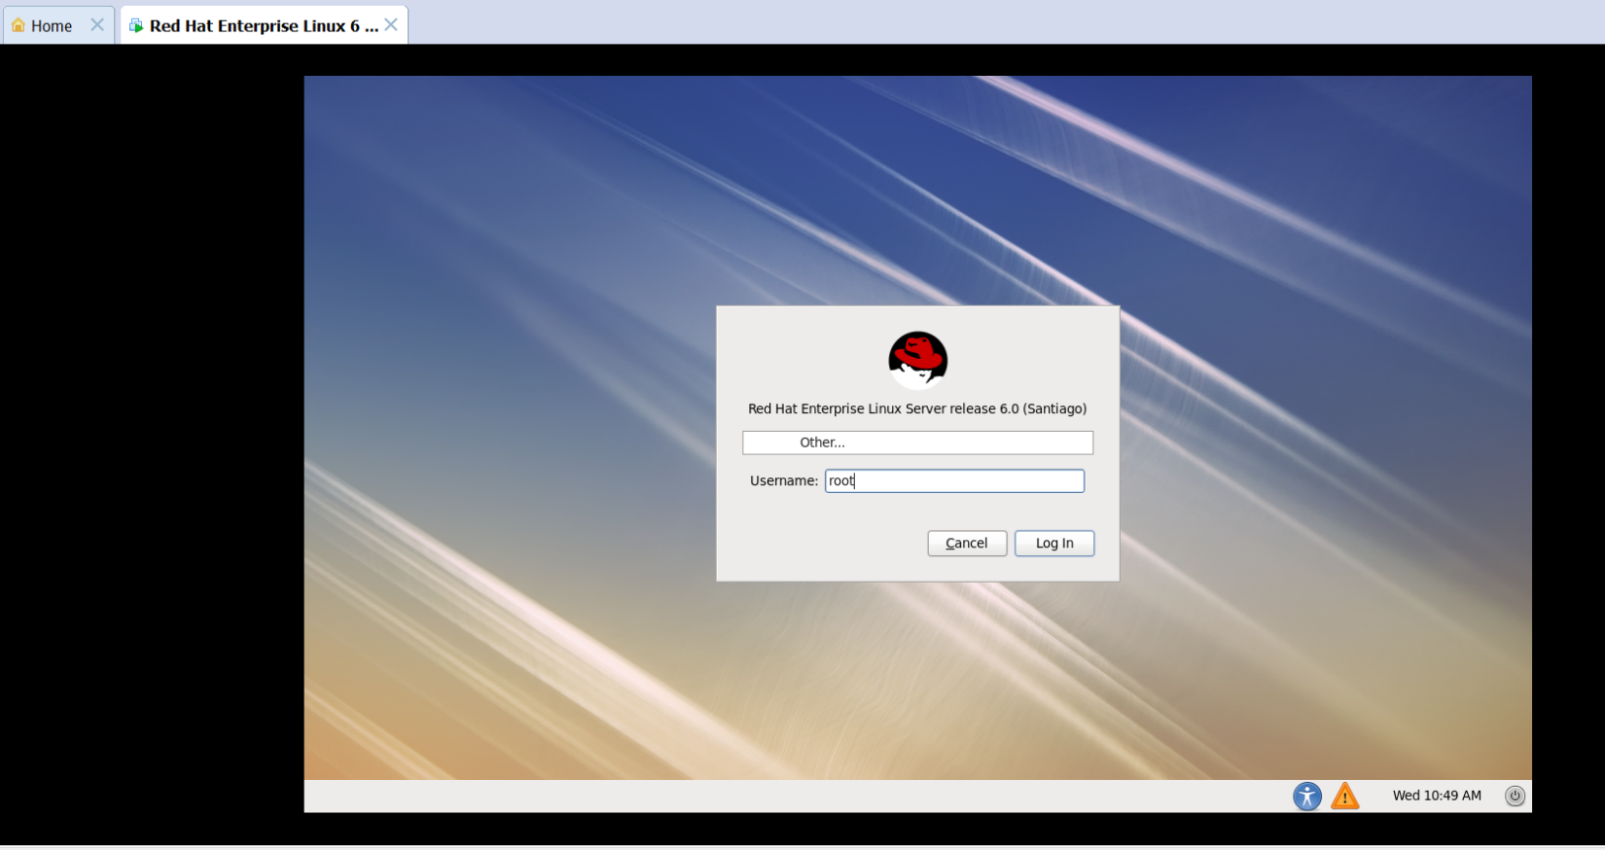

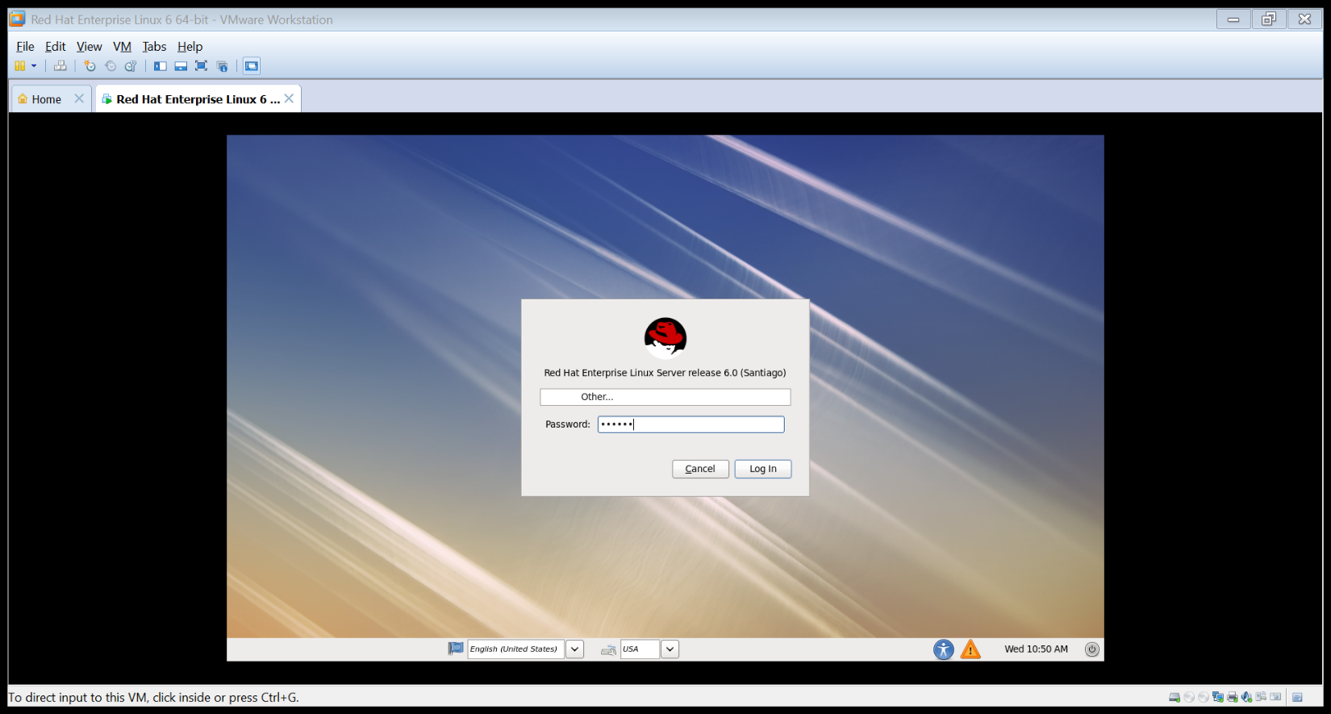

**Step 8:**

Click on the check box in order not to reoccur.

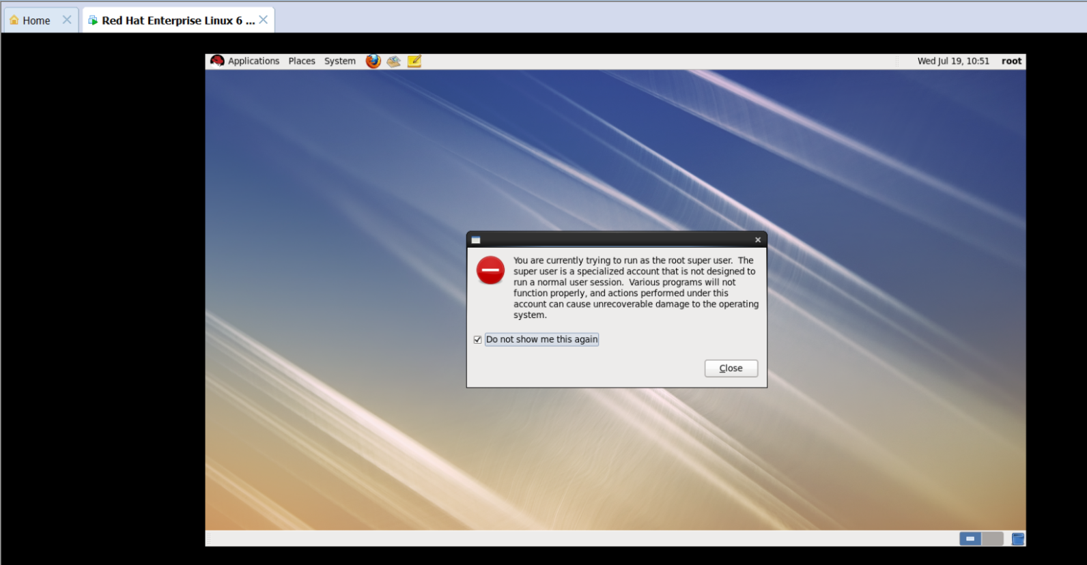

**Step 9:**

Once you are able to see desktop icons, right-click your mouse and click on *Open in Terminal.*

Now its time to start executing unix/linux commands

Enjoy ☺

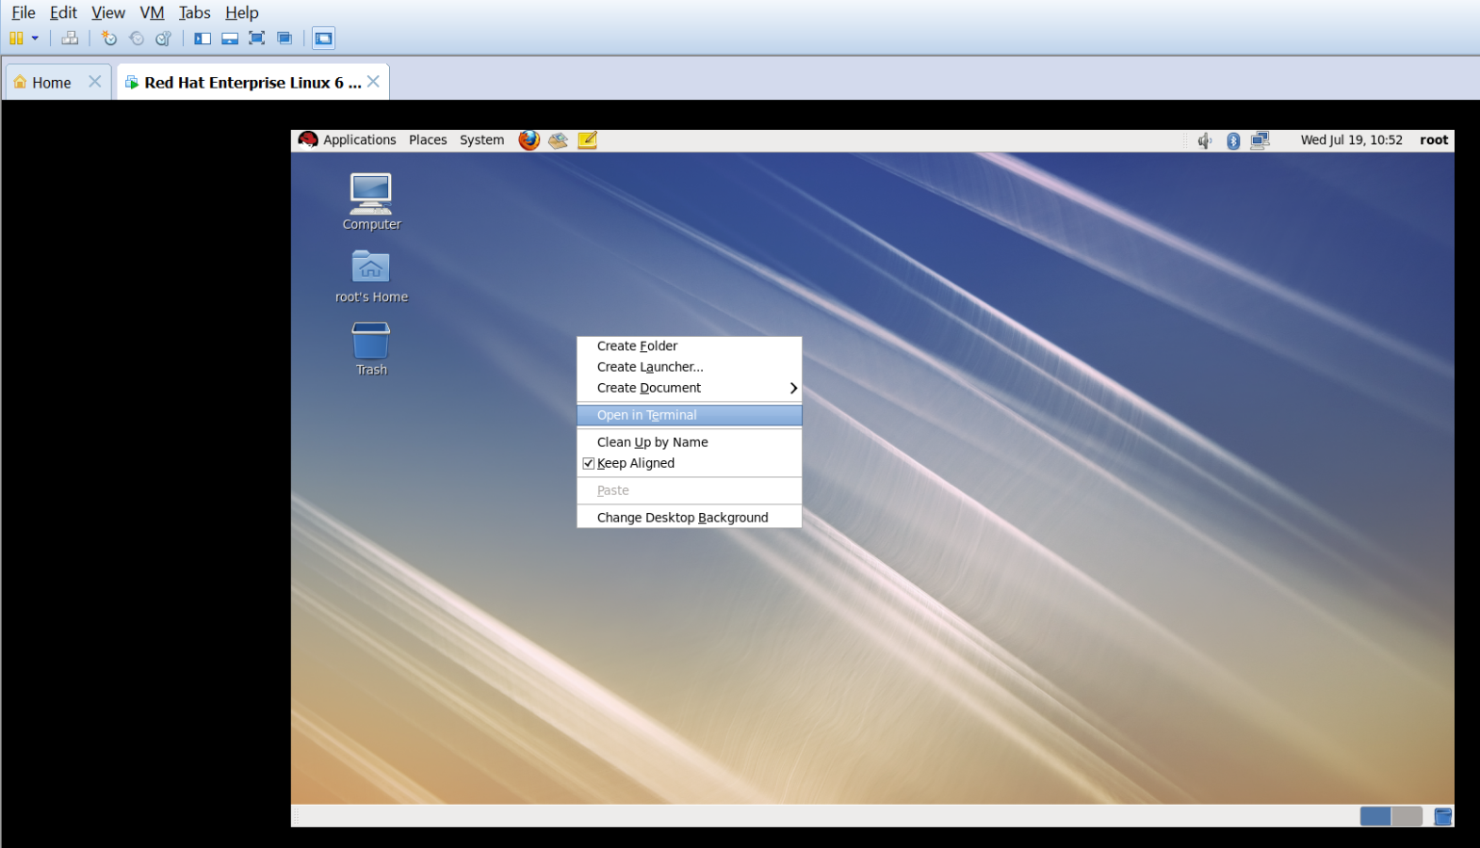

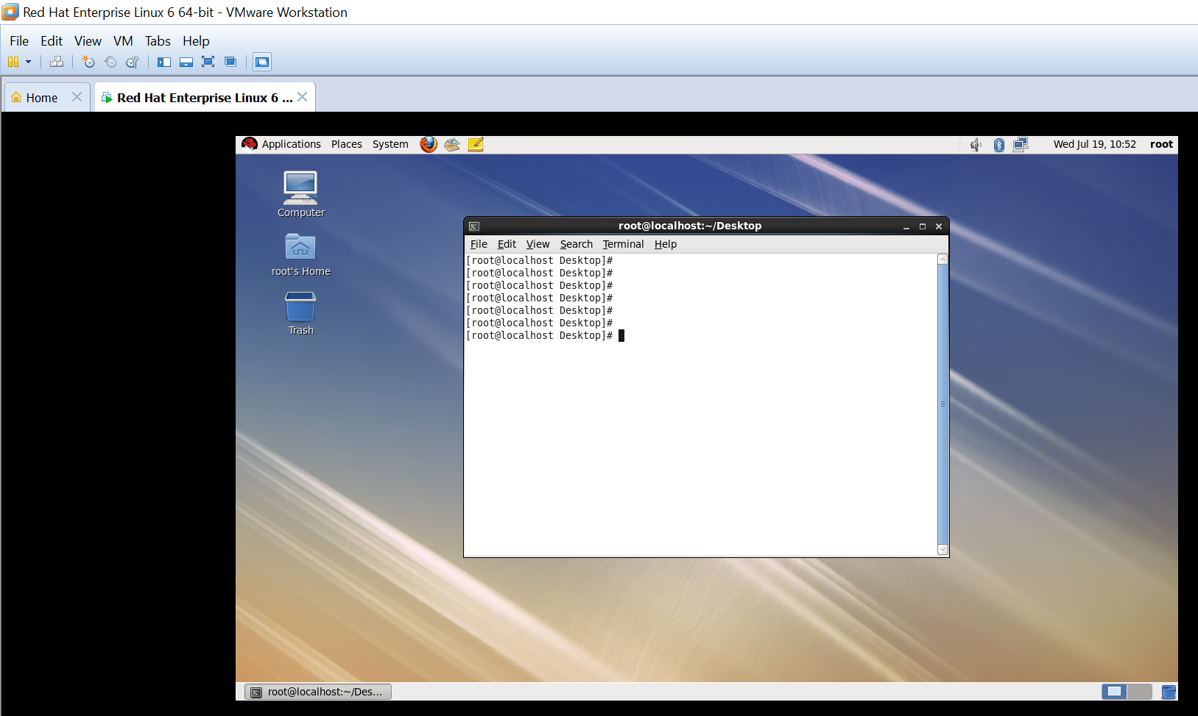

Now, we are done with installation of RHEL 6.0 in VMware tool.

**History**

UNIX evolved at AT&T Bell Labs in the late sixties.

The writers of Unix are Ken Thomson, Rudd Canaday, Doug McIilroy, Joe Ossanna and Dennis Ritchie.

It was originally written as OS for PDP-7 and later for PDP-11.

UNIX OS exhibits the following features:

**Features**

It is a simple User Interface.

It is Multi-User and Multiprocessing System.

It is a Time Sharing Operating System.

It is written in “C” (HLL).

It has a consistent file format - the Byte Stream.

It is a hierarchical file system.

It supports Languages such as FORTRAN, BASIC, PASCAL, Ada, COBOL, LISP, PROLOG, C, C++, and so on.

**Functions**

Process Management

Main-Memory Management

Secondary-Storage Management

I/O System Management

File Management

Protection System

Networking

Command-Interpreter System

**Introduction**

|  |  |
| --- | --- |
| **Unix based OS** | |
| Linux Flavours | Other Unix OS |
| RHEL 5/6/7 | IBM AIX |
| Cent OS | HP UX |
| Ubuntu | Oracle solaris |
| Mandriva | Oracle linux |
| Fedora | Mac |

**Unix Architecture:**

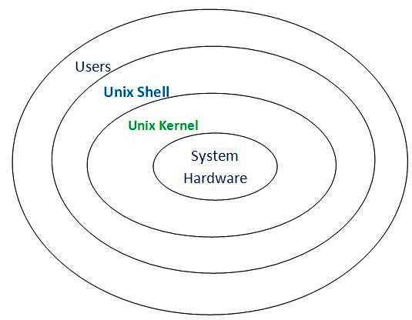

**Unix:** Uniplexed Information and Computing System.

**Kernel:** In unix OS its an code and acts as a bridge between the activities by user and hardware.

**Shell:** It’s a program that interprets commands and acts as like an interface between users and kernel

**Filesystem Hierarchy**

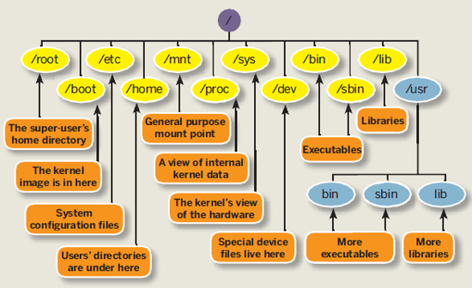

|  |  |
| --- | --- |
| / | base directory |
|  |  |
| /root | This is the home directory of root user and should never be confused with ‘/‘ |
|  | –– |
| /bin | All the executable binary programs (file) required during booting, repairing, files required to run into single-user-mode and other important, basic commands viz., cat, du, df, tar, rpm, wc, history, etc. |
|  |  |
| /sbin | Contains binary executable programs required by System Administrator, for Maintenance. Viz., iptables, fdisk, ifconfig, swap on, reboot, etc. |
|  |  |
| /boot | Holds important files during boot-up process, including Linux Kernel. kernel + os boot loader(grub2)+ kdump |
|  | Till RHEL 4 boot file: LILO |
|  | After RHEL 5 boot file: GRUB  After RHEL 7 boot file: GRUB2 |
|  |  |
| /proc | Its file-system which contains information about running process with a particular pid. No one can create files/folders in this directory |
|  |  |
| /srv | Service is abbreviated as ‘srv‘. This directory contains data files for specific services FTP,WWW, NTP, NFS, DNS |
|  |  |
| /sys | Modern Linux distributions include a /sys directory as a virtual filesystem, which stores and allows modification of the devices connected to the system. This contains info as same as /proc |
|  |  |
| /tmp | System’s Temporary Directory, Accessible by users and root. Stores temporary files for user and system. Files exist till age of 30days. If its more than 30days it ll be automatically deleted. |
|  |  |
| /usr | Contains executable binaries, documentation, source code, libraries for second level program. eg for services (ftp, nfs). Files saved here will be shared across multiple machines. |
|  |  |
| /var | Stands for variable. The contents of this file is expected to grow. This directory contains log, lock, spool, mail and temp files. eg: databases, cache directory, log files, printer spooled documents |
|  |  |
| /etc | Place for service's configuration files like DNS, DHCP, Webserver, FTP, NFS |
|  |  |
| /dev | Contain device files for HDD, CDROM, USB etc |

**Mounting Directories:**

|  |  |
| --- | --- |
| /media | Temporary mount directory is created for removable devices viz., media/cdrom. |
|  |  |
| /mnt | Temporary mount directory for mounting file system. |
|  |  |
| /opt | Optional is abbreviated as opt. Contains third party application software. Viz., Java, etc. Files related to package will be placed under /opt |

**Color coding followed in RHEL:**

White - normal file

Blue - directory/folder

Green - executable file

Sky blue -link file

Red highlighted - setuid permission

Red - .tar file

Green highlighted – sticky bit

**prompt STRING:**

[root@hp ~]#

|  |  |
| --- | --- |
| root | current user |
| hp | hostname of a machine |
| ~ | pwd -present working directory/current directory |
| # | to indicate current user is root user |
| $ | to indicate current user is normal user |

**Command syntax:**

In unix, basic command syntax follows this way.

# command -options argument1 argument2...argumentN

Command -- is a set of program executed in a single transaction

Options -- to change the output format of command

Argument -- input to the commands

|  |  |
| --- | --- |
| # ls | only cmd |
| # ls –l | cmd with option |
| # ls f2 | cmd with argument/input |
| # ls –l f2 | cmd with option and argument |

**# ls –ltrhiSRaFd**

a --hidden files

l -- long list

t -- sort the files based on time modified

r –- reverse

i -- inode number

h -- human readable format for size

S -- sort files based on size

R -- Show contents of all sub folders/files with properties--

F – to differentiate files as normal file, executable file, directory

d - to check the details of directory

**BASIC COMMNAnds**

# date

# cal

# cal -1

# cal -3

# cal 7 2015

# whoami

# hostname

**Help Commands**

# man date **-** (manual page) man ls, man cp, man mkdir

# cp --help

**FILE TYPES:**

**Regular Files (-)**

-rw-r--r--. 1 root root 39K May 6 13:05 install.log

**Directory files(d)**

drwxr-xr-x. 2 root root 4.0K May 6 07:38 Music

**Character file(c)**

Its used to communicate with hardware device with one character at a time ….arun

crw------- 1 ranga users 4, 0 Feb 7 13:47 /dev/tty0

**Block file(b)**

Its used to communicate with hardware device with large blocks. Arun raban van

brw-rw---- 1 root disk 8, 0 Feb 7 13:47 /dev/sda

**Pipe file(p)**

files that act just like temporary anonymous pipes on the command line.

**prw**-r--r-- 1 ranga wheel 0 Nov 22 17:39 mypipe

**a -> pf -> b**

**Link files:**

**Hard link:**

Used to create to links for a file.

**Soft link or symbolic file: (shortcut in MSwin)**

Used to create to shortcuts for files/folders.

lrwxrwxrwx. 1 root root 14 May 25 00:54 system-release -> centos-release

**File and Folder Management**

cat : to concatenate more than one files

|  |  |
| --- | --- |
| # cat > filename | To add content to a file and overwrites previous data |
| # cat >> filename | To append the contents by not disturbing the previous data |
| # cat filename | To view whole contents of file |
| # cat –n filename | To view whole contents of file with line numbers |
| # cat filename1 filename2 | To merge output of two files |

**File :**

# ls –l a1.txt

-rwx rwx rwx 1 root root 0 Aug 31 00:18 a1.txt

set

|  |  |  |  |
| --- | --- | --- | --- |
| - | --- | --- | --- |
| - | Rwx | rwx | rwx |
| file type | file owner (u) | group (g) | others (o) |
|  | a=u+g+o | | |

|  |  |  |
| --- | --- | --- |
| Read | R | 4 |
| Write | W | 2 |
| Execute | X | 1 |

r-- r-- r--.1 root root 0 Aug 31 00:18 a1.txt

- -- type of file (-,d,l,p,b,c,s)

rw- r—r- -- permission ( owner group others)

1 -- no of link to a file/folder

root -- owner of a file

root -- file belongs to a group

0 -- size of a file

Aug 31 00:18 -- last modified date/time

a1.txt -- file/folder name

GNU `ls' uses a `.' character to indicate a file with an SELinux security context, but no other alternate access method.

A file with any other combination of alternate access methods is marked with a `+' character.

**Memory measurement**

8bits - 1byte

1024b - 1kb (kilo byte)

1024kb - 1mb (mega byte)

1024mb - 1gb (giga byte)

1024gb - 1tb (tera byte)

1024tb - 1pb (peta byte)

1024pb - 1eb (exa byte)

1024eb - 1zb (zetta byte)

1024zb - 1yb ( yotta byte)

**Copy, rename, move, remove file/directoRY**

**Files:**

|  |  |
| --- | --- |
| # cmd <options> <source-path> <destination-path> | Syntax |
| # cp -v 1.log /dev  # cp -vp 1.log /dev | Copying file 1.log to /dev directory  -v, verbose, to show status of a command  -p, preserve, to copy file/directory with original date/time to another directory. |
| # mv -v 1.log 2.log | Renaming file from 1.log to 2.log |
| # mv -v 2.log /dev | Moving file 2.log from current directory to /dev directory |
| # rm -v 3.log | Removing file 3.log |

/d1

/d2

/d3

/d4

**Directories:**

|  |  |
| --- | --- |
| # mkdir college | to create directory in the current directory |
| # mkdir /school | to create directory under / |
| # mkdir -p /d11/d12/d13 /d21/d22/d23 | to create directory with parent and child relationship |
| # mkdir –p /school/{a,b,c} | to create multiple directories |
| # mkdir /school/{1..10} | to create multiple directories using ranges |

|  |  |
| --- | --- |
| # cd | this ll take u to current user's home directory |
| # cd .. | this ll take u 1 level back from the current directory |
| # cd ../.. | this ll take u 2 levels back from the current directory |
| # . | this indicates pwd (present working directory) |
| # cd ~ | this ll take u to current user's home directory |

|  |  |
| --- | --- |
| # cmd <options><source-path><destination-path> | Syntax |
| # cp -r log /dev  # cp -rvp log /dev | Copying directory log to /dev directory  -v, verbose, to show status of a command  -p, preserve, to copy file/directory with original date/time to another directory. |
| # mv -v log exe | Renaming log directory to exe |
| # mv -v 2.log /dev | Moving directory log from current directory to /dev directory |
| # rm -rv log | Removing directory log |

**Absolute Path:**

To copy a file/dir starting from the head of the path.

It should start with /

# cp -v /ss /tmp/govind/

# cp -rv /root/arun/ /tmp

**Relative Path:**

To copy/move a file/dir by having pwd(present working directory) as reference path.

**/d1/d2/d3**

D3]# cp -v ../ss /tmp/govind/

D3]# cp -rv ../../csc /tmp

# cp *.log *.pdf ~

Considering the directory structure as /d1/d2/dam/d3/d4

|  |  |  |
| --- | --- | --- |
|  |  |  |
| Copying directory dam to d4 | Source Path | Destination Path |
| d2]# cp -rv /d1/d2/dam /d1/d2/dam/d3/d4 | Absolute | Absolute |
| d2]# cp -rv dam /d1/d2/dam/d3/d4 | Relative | Absolute |
| d2]# cp -rv /d1/d2/dam d3/d4 | Absolute | Relative |
| d2]# cp -rv dam d3/d4 | Relative | Relative |

**Link Files:**

**Hard link:**

Same inode number and same permission

Can create only within a same partition

If original file is deleted, then link file will exist.

Applicable for only files

Files manipulation affects both the files.

# ln <original_file> <link_file>

# ln file1 file1_hl -- syntax to create hardlink

# ls -li file1 file1_hl -- to view files with inode numbers

1835659 -rw-r--r--. 2 root g7 25 Jul 12 21:06 file1

1835659 -rw-r--r--. 2 root g7 25 Jul 12 21:06 file1_hl

**Soft link or symbolic file: (shortcut in MSwin)**

Can create with different partition in different filesystems.

Different inode number and different permission.

If original file is deleted, then link file will not exist.

Applicable for both files/folders.

Files manipulation affects both the files.

# ln -s /root/file2 /dev/file2_sl (shortcuts in windows) -- syntax to create softlink

# ls -li /root/file2 /dev/file2_sl

219182 lrwxrwxrwx. 1 root g7 5 Jul 12 21:10 /dev/file2_sl -> file2

835747 -rw-r--r--. 1 root g7 22 Jul 12 21:09 file2

**Virtual Editor**

File editing tool

**vi/vim**

**vi modes:**

ESC mode : press esc key

INSERT mode : press i key

COMMAND mode : press shift :

insert mode -------🡪 esc---🡪 command mode

command mode---🡪 esc---🡪 insert mode

VISUAL Mode

:q quit

:q! force quit

:w Write(save) alone

:wq Write(save) and quit

:wq! force Write(save) and quit

# vi <filename>

--commands with : should be executed in command mode

--commands without : should be executed in esc mode

|  |  |
| --- | --- |
| **copy, cut, paste, delete** | |
| <n>yy | to copy - 5yy (y-yank) |
| 10yy | copies 10 lines from the cursor |
| Yw | copy single word |
| <n>yw | copy no.of words |
| P | to paste |
| <n>cc | to cut |
| 10cc | cuts 10 lines from the cursor |
| cw | cuts single word |
| <n>cw | cuts no.of words |
| x or delete key | to delete single character |
| Dw | to delete single word |
| <n>dw | to delete n no of single word |
| <n>dd | to delete single line, |
| 10dd | delete 10 lines from the cursor |
| **cursor movement** | |
| Shift + a | To move end of line and change to INSERT mode |
| Shift + d | After cursor position, data will be deleted. |
| gg | it takes to first line of file |
| G | it takes to last line of file |
| :101 | to move cursor to the particular line number |
| **Viewing more than 1 files** | |
| :split <filename> | to read other file (we can include n no of files, cp ct also possible |
| ctrl + ww | to shift the cursor between the files |
| :read <filename> | to copy contents from other file to the current file |
| :!<cmd> | to execute cmd inside vim |
| :wq <filename> | to save as the another filename |
| **search and replace** | |
| :/<word> | to search the words (n-forward search, N-backward search) |
| :s/old/new | Finds each occurrence of ‘old’ (in the current line only) and replace it with ‘new’ |
| :%s/old/new/ | Finds each occurrence of ‘old’ (in all lines) and replace it with ‘new’ |
| :%s/old/new/g | replace all old with new throughout file, g global |
| :%s/old/new/gc | replace all old with new throughout file with confirmations, c confirmation |
| :%s/\<foo\>/boo/ | changes only whole words exactly matching 'foo' to 'bar' |
| %s/foo/boo/gi | to replace with case insensitive |
| :s/\(hello\|hai\)/hi/g | Replace changes with more than one word in source |
| :s/\v(hello|hai)/hi/g |  |
| :2s/old/new/ | replace the changes at 2nd line |
| :2,5s/old/new/ | Replace the changes from 2nd to 5th line |
| :.,$s/foo/bar/g | change each 'foo' to 'bar' for all lines from current line (.) to the last line ($) |
| :.,+2s/foo/bar/g | change each 'foo' to 'bar' from current line (.) to next two lines (+2). |
| :g/^baz/s/foo/bar/g | change each 'foo' to 'bar' in each line starting with 'baz' |
| **set options can be manually used when required or use permanently by making a entry in ~/.exrc file** | |
| :set nu | to set line numbers |
| :set nonu | to remove the line numbers |
| :set list | to show end of a line |
| :set ic | to remove case sensitive during the search |
| :set ruler | to show row and column positions |

**[root@server ~]# cat /root/.exrc**

set nu

set list

set ruler

**touch** :to change the file/directory timestamps

|  |  |
| --- | --- |
| # touch filename | To create a empty file |
| # touch filename1 filename2 filename3 | To create multiple empty files |
| # stat filename | To get statistics of a file |
| # touch –a filename | To change access time for a file |
| # touch –m filename | To change modified time for a file |
| # touch –m *.log | To change modified time for the .log extension file |
| # touch –c filename | To change a, m, c time with current server time |
| # touch -t 199901010101.01 filename | To change date/time as per user desire |
| # touch -d "2012-10-19 12:12:12.000000000 +0530" tgs.txt | To change date/time as per user desire |
| # touch filename1 –r filename2 | To change the timestamp of filename1 w.r.t filename2 |

**Filters**

**head:** to display top of file

# head <filename> -- to view first 10 lines of a file

# head -n <filename> -- to view n no of lines of a file

# head -3 <filename> -- to view first 3 lines of a file

# head –n -3 <filename> -- to view all lines expect last 3 lines of a file

**tail:** to display bottom of file

# tail <filename> -- to view last 10 lines of a file

# tail -n <filename> -- to view last n no of lines of a file

# tail -4 <filename> -- to view last 4 lines of a file

# tail –n +2 <filename> -- to view all lines expect first 2 lines of a file(used when filtering files with header)

**less:** to display file contents in moving the cursor up and down.

U can go both upwards and downwards.

Using spacebar, file will be scrolled page by page

Using enter, file will be scrolled line by line.

# less <filename>

**Pipeline:** considering output of first command as a input for the second command

# cmd1 -->o/p | ---> i/p cmd2

**nl** numbers of line in a file

# nl -i2 emp.txt

# nl -v 0 emp.txt

# nl -v 10 emp.txt

# nl -v 0 -i5 emp.txt

# nl -v 10 -i5 emp.txt

**grep**

-- global regular expression print

-- capture the matching pattern from the files/command

**Syntax:**

# grep <options> <pattern> <filenames>

|  |  |
| --- | --- |
| # grep is example-grep.txt | string match |
| # grep color is example-grep.txt | to print matching string in color |
| to make this as permanent , add a entry in /etc/environment as env variable, |
|  | export BASH_OPTIONS=color |
| # grep "is" file1.txt example-grep.txt | using grep for more than 1 file |
| # grep -w is example-grep.txt | w exact word match |
| # grep -wi "Data entry hi hello" example-grep.txt | i removes case sensitive |
| # grep -A 2 -w 'is' example-grep.txt | A to print 2 lines after the match..line numbers can be any |
| # grep -B 2 -w 'is' example-grep.txt | B to print 2 lines before the match..line numbers can be any |
| # grep -C 2 -w 'is' example-grep.txt | C to print 2 lines before and after the match..line numbers can be any |
| # grep -r "arun" * | to search the pattern in all files under current directory |
| # grep -v "arun" * | to search the pattern expect the string "arun". |
| # grep -c "arun" example-grep.txt | counts no.of matching pattern |
| # grep –vc | to find out no.of lines that does not match |
| # grep "default=0" /etc/* | to search in particular directory |
| # grep -l "arun" * | print the file names alone containing the pattern "arun" |
| # grep -n "arun" * | print the matching string with the line numbers from the file |
| # egrep "arun|vishak" example-grep.txt | to search the pattern for more than 1 string arun and vishak (e extended) . | this is alternative operator in reg.exp |
| # egrep '^hi|hello$' example-grep.txt | to find the lines starting(^) with string "hi" or ending($) with string "hello" |
| # egrep '^.{47}3' example-grep.txt | to find a pattern from a position. 47th is a position |

**Meta characters** - * ? [] ! ^ $

* display string with one or more matching character

? display string with single matching character

[afc] display files/folders names starting with a or f or c

[0] display files starting with 0

[01] display files starting with 0 and 1

[a-f] Range wise

[a-zA-Z1-9] display strings with combination of 3 characters for 1st position alone, a-z or A-Z or 1-9

[a-z][A-Z][1-9] display strings with combination of 3 characters for 1st,2nd,3rd positions a-z and A-Z and 1-9

a[\!]

[!a]*.txt display files and folders which are not starting with the letter a.

[!ap]*.txt

[!a-e]*.txt

#ls -l ar*

#ls -l ?ndia

#ls -l ??jan.txt

#ls -l 01??2015.txt

#ls -l [afc].txt

#ls -l [a-zA-Z1-9].txt

#ls -l [a-z][A-Z][1-9]report.txt

#2[0-9][0-9].fin

**SORT:**

[root@localhost ~]# cat emp

praveen m 22 analyst 30000 May 15-05-2016

saba f 23 analyst 40000 Jan 22-01-2016

lakshi f 42 manager 60000 Sep 05-09-2016

saks3 f 42 manager 60000 Sep 05-09-2014

sakshi m 3 anager 60000 Mar 22-03-2016

nilan m 36 assistant 800 Apr 05-04-2016

nilan m 36 assistant 800 Apr 05-04-2016

ankit m 28 architect 7000 Jun 11-06-2016

bavana f 30 tester 10000 Dec 02-12-2016

bavana f 30 tester 900 Dec 02-12-2016

rasheed m 32 developer 9000 Jul 16-07-2016

ghosh m 29 consultant 80000 Oct 08-10-2016

ghosh m 29 consultant 80000 Oct 08-10-2016

shreya f 33 vendor 5000 Nov 26-11-2016

shreya f 33 vendor 5000 Nov 26-11-1999

shreya f 33 vendor 5000 Nov 26-11-2009

shreya f 33 vendor 5000 Nov 06-11-2009

shreya f 33 vendor 5000 Nov 09-11-2009

|  |  |
| --- | --- |
| sort filename | normal sort |
| sort -r filename | reverse sort |
| sort -u filename | prints unique records by eliminating duplicate records |
| sort -k2 filename | -k, column wise sort |
| sort -nk5 filename | sort 5th column by numeric |
| sort -Mk6 emp | sort 6th column by month wise |
| sort -nk7 emp | sort -rnk7.4 | sort 7th column by numeric, then sort the 4th character from 7th column |
| sort -k4,4 -k5,5n emp | sort 4th first, then based 4th column sort the 5th column |
| sort -t',' -k2 filename | -t delimiter, when , is a delimiter |
| sort -t $'\t' -k1.3 | when tab space is a delimiter |

**cut:**

Nilan:m:36:assistant

Ankit:m:28:architect

bavana:f:30:tester

bavana:f:30:tester

rasheed:m:32:developer

ghosh:m:29:consultant

shreya:f:33:vendor

shreya:f:33:vendor

|  |  |
| --- | --- |
| cut -cn filename | character wise |
| cut -cn-n filename | Range |
| cut -c10-15 filename | will cut from 10th to 15th position |
| cut -c10- filename | from 10th position to end of the line |
| cut -d':' -f3 filename | delimiter, column wise |
| cut -d':' -f1,2 filename | delimiter, column in range |
| cut -d' ' -f-3,6 filename | delimiter, column in range and individual |
| cut -d $'\t' -f1 bb | when tab space is a delimiter |

**tr:**

Usage: tr [OPTION]... SET1 [SET2]

Translate, squeeze, delete characters from standard input writing to standard output.

-d, --delete delete characters in SET1, do not translate

-s, --squeeze-repeats replace each input sequence of a repeated character into single character.

**Eg:**

[root@server ~]# echo "hi boss, i ll be in office at 22-11-12" | tr -s 2

hi boss, i ll be in office at 2-11-12

[root@server ~]# echo "hi boss, i ll be in office at 22-11-12" | tr -s s

iihi bos, i ll be in office at 22-11-12

[root@server ~]# echo "hi boss, i ll be in office at 22-11-12" | tr -d 2

hi boss, i ll be in office at -11-1

[root@server ~]# echo "hi boss, i ll be in office at 22-11-12" | tr -d ' '

hiboss,illbeinofficeat22-11-12

[root@server ~

# echo "hi boss, i ll be in office at 22-11-12" | tr -s ' '

hi boss, i ll be in office at 22-11-12

[root@server ~]# echo "hii^ iii^ h^hh hel$ llllo " | tr -d '^$'

hii iii hhh hel llllo

[root@server ~]# echo "hi boss, i ll be in office at 22-11-12" | tr -s ' '

hi boss, i ll be in office at 22-11-12

[root@server ~]# echo "hi boss, i ll be in office at 22-11-12" | tr [a-z] [A-Z]

HI BOSS, I LL BE IN OFFICE AT 22-11-12

[root@server ~]# echo "hi boss, i ll be in office at 22-11-12" | tr [:lower:] [:upper:]

HI BOSS, I LL BE IN OFFICE AT 22-11-12

[root@server ~]# echo "hi boss, i ll be in office at 22-11-12" | tr [b] [bb]

hi boss, i ll be in office at 22-11-12

[root@server ~]# echo "hi boss, i ll be in office at 22-11-12" | tr ['' 'bb'

hi boss, i ll be in office at 22-11-12

[root@server ~]# echo "hi boss, i ll be in office at 22-11-12" | tr 'b' 'bb'

hi boss, i ll be in office at 22-11-12

[root@server ~]#

[root@server ~]# echo "hi boss, i ll be in office at 22-11-12" | tr 'b' 'bb'

hi boss, i ll be in office at 22-11-12

[root@server ~]# echo "hi boss, i ll be in office at 22-11-12" | tr 'hi' 'bb'

bb boss, b ll be bn offbce at 22-11-12

[root@server ~]# echo "hi boss, i ll be in office at 22-11-12" | tr 'h' 'bb'

bi boss, i ll be in office at 22-11-12

[root@server ~]# echo "hi boss, i ll be in office at 22-11-12" | tr '2' '3'

hi boss, i ll be in office at 33-11-13

[root@server ~]# echo "hi boss, i ll be in office at 22-11-12" | tr '2' '33'

hi boss, i ll be in office at 33-11-13

[root@server ~]# echo "hi boss, i ll be in office at 22-11-12" | tr 's' '@'

hi bo@@, i ll be in office at 22-11-12

**TEE:**

Used to send the output to more than one stream.

As like name “T”, having one source of input and two dimensions of outputs.

# <cmd1> | tee <filename> | <cmd2>

#sort emp.dat | tee tempfile | cut –f 3

# cut –d’ ‘ –f1 emp | tee log | head -3

**Word Count:**

# wc -lwc <filename>

l -- provides no.of lines in a file

w -- provides no.of words in a file

c -- provides no.of characters in a file

# who | wc -l

# head -1 /etc/passwd | wc -c

**History**

To execute the previously executed commands from a history file.

|  |  |
| --- | --- |
| # history | to view previously executed command |
| # !! | to execute previous cmd |
| # !6 | to execute previously executed cmd from the history |
| # history -c | clear the history for a current session only. |
| ~/.bash_history | saves all the cmds in a file |
| # export PROMPT_COMMAND='history -a' | Append the new history lines to the history file. |
| # export HISTSIZE=5000 | keep the last 5000 entries |
| # export HISTCONTROL=erasedups | ignore duplicate commands |
| # export HISTTIMEFORMAT='%F %H:%M' | changes the time format in history file |
| shopt -s histappend | append to the history instead of overwriting (good for multiple connections) |

**Permission**

**Octal notation Permission:**

#chmod 777 f1.txt

#chmod 640 f1.txt

**Alphabet Permission:**

chmod u+rwx,g+rwx,o+rwx f1.txt

chmod u+r f1.txt

chmod g-w f1.txt

chmod a+rwx f1.txt

chmod a-x f1.txt

**Default permission:**

**root**:

file : 644/666 -- 022

directory : 755/777 -- 022

**normal user:**

file : 664/666 -- 002

directory : 775/777 -- 002

**Umask Value:**

: Setting which determines what permissions are applied to a newly created file or directory is called a umask value

: By using this value, default value can be assigned.

: Umask value is inversely proportional to file/dir permission.

root:

file/directory : 022 - 644

normal user :

file/directory : 002 - 664

/etc/profile - file to edit umask value as permanent.

#umask 000

Umask value is inversely proportional to file/dir permission.

**File Descriptors:**

stdin 0 I/P

stdout 1 O/P

stderr 2 ERR

|  |  |
| --- | --- |
| > | Overwrite the Contents or Redirecting |
| >> | Appending the previous data |
| < | Getting input from a file/user |
| 1> | Re-directing output to a file |
| 2> | Re-directing error to a file. |
| & | Re-directing to same terminal. |
| /dev/null | Error bucket, incoming data will be trashed immediately |

#cat f1 f3 2> op1.txt

#cat f1 f2 2>/dev/null

#cat f1 f2 1>op.log 2>&1

1. output msg of f1 f2 is re-directed to op.log file

2. error msg is also re-directed to same file where output msg is getting redirected.

# cat f1 f2 1>op.log 2>&1

First, the output got re-directed to the file op.log

2>&1 - This means re-directing the error(2) to the same terminal as the output(&1). Since output is re-directed to op.log, the error msg is also redirected to op.log.

#cat f1 f2 2>&1 1>op.log

**This will not work as expected.**

2>&1 - First, the error got re-directed to the same place as the output. Since the output re-direction is not defined yet, the error gets re-directed to its default terminal itself.

Secondly, the output is now re-directed to the file op.log. So, on running the above command, all the output gets re-directed to the output file op.log and the errors are captured in the terminal itself.

**Process**

When you execute a program on your UNIX system, the system creates a special environment for that program. This environment contains everything needed for the system to run the program as if no other program were running on the system.

Whenever you issue a command in UNIX, it creates, or starts, a new process. When you tried out the ls command to list directory contents, you started a process. A process, in simple terms, is an instance of a running program.

The operating system tracks processes through a five digit ID number known as the **pid** or process ID . Each process in the system has a unique pid.

**Daemons** - Daemon does not stand for Disk and Execution Monitor. They are the processes which run in the background and are not interactive. They have no controlling terminal. They perform certain actions at predefined times or in response to certain events. In UNIX, the names of most daemons end in d.

**Services** - In Windows, daemons are called services.

**Process** - Process is a running program. At a particular instant of time, it can be either running, sleeping, or zombie (completed process, but waiting for it's parent process to pick up the return value).

|  |  |
| --- | --- |
| # ps | list process running in current shell |
| # ps –u | list current user's process |
| # ps -u raj | list only user raj process |
| # ps -ef | list full information of current user process |
| # ps –e | list all (root, normal users) process |
|  |  |
| Pid | process id with 5 digit numbers |
| Ppid | parent process id |
| # top | to get cpu/memory/process status |
| # kill –l | lists signals |
| # kill <pid> | graceful kill. |
| # kill -9 <pid> | immediate kill for a process id (-9 signal to terminate) |
| # pkill <pname> | to kill with a process name |
| # kill -stop <pid> | to hold a process |
| # kill -cont <pid> | to resume the process |
| Fg | foreground process |
| Bg | background process |
| & | to run a job in the background |
| # jobs –l | to list all the background(bg) running process with pid |
| # kill %2 | to kill bg jobs with job number |
| # fg | this will bring recent bg job to fg. |
| # fg %20 | this will bring required bg job using their job number to fg. |
| # nohup | to run a process directly in the server i.e without any terminal connection |
|  |  |
| # cat /dev/zero > /dev/null | to create a process |
| ctrl + z | To suspending a process |
| ctrl + c | to terminate a process |
| # jobs –l | to list background(bg) process for current terminal |
|  | to bring background(bg) process to foreground(fg) |
|  |  |
|  |  |

**Difference between kill and kill -9:**

Kill will generate a SIGTERM signal asking a process to kill itself gracefully i.e , free memory or take care of other child processes. Killing a process using kill will not have any side effects like unrelased memory because it was gracefully killed.

Kill -9 works similarly but it doesn't wait for the program to gracefully die. Kill -9 generates a SIGKILL signal which won't check the state of the process and kills the process immediately.

**FIND**

To search the files and directories with the required options in whole hard disk.

User has to have rx permission on searching directory.

# find <path> <options>...... <actions>

|  |  |
| --- | --- |
| **using –name** |  |
| # find / -name Tecmint | finds both file and directory |
| # find / -name *.sh -o -name *.log | find two file names in a same time. |
| **using –type** |  |
| # find / -type d -name Tecmint | finds directory |
| # find / -type f -name Tecmint | finds files |
| # find / -type f -iname Tecmint | remove case sensitive |
| # find . -type f -not -name "*.d" | find filename excluding *.d files |
| # find / -type f -empty | find empty files |
| # find / -type d -empty | find empty directories. |
| # find / -type f –links +1 |  |
| # find / -type l | find link files alone. |
| # find / -type b | find block files alone. |
| **using –size** |  |
| # find / -size +50M -size -100M |  |
| # find / -size +100M |  |
| **using –mtime** |  |
| **+5 -- 1 2 3 4 5 6 7 8 9 10 11** 12 13 14 15 16  **-5 --** 1 2 3 4 5 6 7 8 9 10 11 **12 13 14 15 16**  **-2 --** 1 2 3 4 5 6 7 8 9 10 11 12 13 14 **15 16**  **2 --** 1 2 3 4 5 6 7 8 9 10 11 12 13 14 **15** 16  **3 --** 1 2 3 4 5 6 7 8 9 10 11 12 13 **14** 1516 |  |
| # find /dev -mtime +5 | (modified time) before 5days (+5 -- before 6th ) |
| # find /var/spool -mtime -5 | within 5days from the current date |
| # find /var/spool -mtime 5 | with exact 5th day from the current date |
| **using –mmin** |  |
| # find / -mmin 120 |  |
| # find / -mmin +200 |  |
| # find / -mmin -150 |  |
| **using –perm** |  |
| # find / -type f -perm 666 |  |
| # find / -type f -perm 642 |  |
| # find / -perm +2000 | to find SGID files - Sticky bit group id |
| # find / -perm +4000 | to find SUID files - Sticky bit user id |
| **using –user** |  |
| # find /home -group ftpusers |  |
| # find /data/project -group ftpusers -name "*.c" |  |
| **using –group** |  |
| # find /data/project -group ftpusers -iname "*.c" |  |
| # find directory-location -user {owner} -name {file-name} |  |
| **Execlude directories** |  |
| # find / -type f ! -path "/proc/*su" -size +100M | Finding files sizes in whole hard disk which has more than 100mb size by excluding /proc directory |
| **Action:** |  |
| : -exec "action" {} \; |  |
| # find . -type f -empty -exec /bin/rm -rf {} \; | to delete empty files in PWD |
| # find . size +50M -exec cp {} ./Desktop \; | to cp files having size more than 50MB to Desktop folder |
| # find / -type f -exec "grep -H 'gulshan'" {} \; |  |
| # find . -type f -empty -exec rm -rf {} \; -print | find a string in which file in exists in whole hd, H print filenames |
| # find / -type f -name '*.tar.gz' -mtime +5 -exec rm {} \; |  |

**ALIAS:**

Instructs the shell to replace one string with another when executing commands.

Aliases are used to customize the shell session interface.

Using alias, frequently-used commands can be invoked using a different, preferred term; and complex or commonly-used options can be used as the defaults for a given command.

Aliases persist for the current session. They can be loaded at login time by modifying the shell's .rc file. The invocation and usage of alias differs depending on the shell;

|  |  |
| --- | --- |
| # alias a ='cat /etc/passwd' | create a temporary alias as "a" |
| # a | execute the command as "a" |
| # alias b='cat /etc/group' | create a temporary alias as "b" |
| # b | execute the command as "b" |
| # alias dir='cd /d1/d2/d3/d4/d5/d6' | add this entry in .bashrc to make alias permanent |
| # dir | execute the command as "dir" |

**SLEEP:**

The sleep command is used to delay for a specified amount of time.

The sleep command pauses for an amount of time defined by NUMBER.

SUFFIX may be "s" for seconds (the default), "m" for minutes, "h" for hours, or "d" for days.

[root@localhost ~]# cat aa

date

echo " perl "

sleep 2 #wait for 2seconds

echo

date

echo " python "

sleep 1m #wait for 1minute

echo

date

echo " ruby "

sleep 2m 30s

echo

date

echo " splunk "

sleep 2m 30s

echo

date

**SHELL SCRIPTING**

**Shell**

It’s a user interface to communicate with OS for executing commands.

User - > shell - > kernel -> hardware

Types –

**sh, bash** (bourne again shell),

ksh(korn shell),

zsh,

C (csh, tsh)

# ps

# echo $SHELL

**Shell Script**

Its program file with many commands are placed in, to execute one by one.

It is useful to run many task by accepting input from user and provide output.

Both interactive and non-interactive shell script can be prepared.

Everyday task can be automated by shell script.

|  |  |
| --- | --- |
| # ps | prints current shell |
| # echo $SHELL | prints current shell |
| # printenv SHELL | prints current shell |
| # echo $BASH_VERSION | prints bash version |

**Bash Versions:**

3.2.25(1) - release EL5

4.1.20(1) - release EL6

4.2.20(1) - release EL7

**Variables:**

variable in capital letters are **SYSTEM DEFINED** variables. echo $SHELL

variable in small letters are **USER DEFINED** variables. echo $a

**Type of Variables:**

1 Local variables

2 Environmental or Global variables

3 Shell variables

**Local variables:**

Variables used within the shell.

Variables not used for all the shells running in the system.

# a=apple -– assigning a variable

# echo $a -- calling a variable

# b=batch -- this type of variable is called as **scalar** variable

# echo $b

# files=(/etc/passwd /etc/shadow /etc/group) -- this type of variable is called as **array** variable

# echo ${files[0]}

# echo ${files[1]}

# echo ${files[2]}

**Shell variables:**

# vi firstscript.sh

#!/bin/bash

echo "File Name : $0"

echo "First Argument : $1"

echo "Second Argument : $2"

echo "Quoted Values : $*"

echo "Total Number of Arguments : $#"

echo “PID of current script : $$”

echo “PID of last background process : $!”

echo “Exit status of this script : $?”

[root@localhost ~]# sh 123 java linux

File Name : 123

First Argument : java

Second Argument : linux

Quoted Values : java linux

Total Number of Arguments : 2

PID of current script : 2545

PID of last background process :

Exit status of this script : 0

#echo $?

0 success

#echo $?

1 error

**Environmental or Global variables:**

This variable is used by all shells in the system.

# echo $PATH

# echo $HOME

# echo $PS1

# echo $USER

# echo $SHELL

|  |  |
| --- | --- |
| # export <variable-name> | used to make variable available in all shells(parent shell, sub shell) |
| # export –n <variable-name> | to remove variable temporarily from export list. |
| # printenv | prints all env variables |
| # env | prints all env variables |

**To make variable permanent.**

# vi .bash_profile

a1=linux.com

export a1=linux.com

If variable settings needs to be global (i.e ALL users to have them) modify system profiles such as /etc/profile.

**PATH:**

* The PATH is an environment variable.
* It is a colon (:) delimited list of directories that your shell searches through when you enter a command.
* All executables are kept in different directories on the Linux and Unix like operating systems.

**To check current values of PATH variable:**

# echo $PATH

/usr/local/sbin:/usr/local/bin:/sbin:/bin:/usr/sbin:/usr/bin:/root/bin:/root/bin:/oracle

**To add directories permanently in PATH variable:**

# cat ~/.bash_profile

# .bash_profile

# Get the aliases and functions

if [ -f ~/.bashrc ]; then

. ~/.bashrc

fi;

# User specific environment and startup programs

export PATH=$PATH:$HOME/bin:/oracle

**Prompt String:**

* PS1 (Prompt String 1) is one of the prompts available in Linux/Unix.
* When you try to login to any machine, you have to enter user name and password.
* Once you are done with this you are presented with some info like who logged in, on what machine he logged in, what is his present working directory and if the logged in user is a super user or a normal user.
* This is done by using PS1 prompt which is a inbuilt shell variable.

# export PS1=”[\u@\h \w]\$ “

# export PS1=”[\h \d \t \u:\w]\$ "

# export PS1="\u@\h[ \$(date +%k:%M) ]\w:"

# export PS1=”\[\e[1;32m\][\u@\h \W]\$\[\e[0m\] “

# export PS1=”\s-\v\$”

If you want to show this prompt show after you reboot, add the same variable to your ~/.bash_profile or ~/.profile with respect to your currect shell.

.bash_profile -- to add the variable

.bashrc -- contains system environment settings

**# cat /etc/profile**

# cat /etc/bashrc

i=idea

echo "hi .........welcome..........$LOGNAME"

a=`date +%r | tr ' ' : | awk -F: '{print $1":"$2" "$4}'`

export PS1="\u@\h[\$(date +%d-%h) \$a]\w:"

~/.bash_profile is the place to put stuff that applies to your whole session, such as programs that you want to start when you log in (but not graphical programs, they go into a different file), and environment variable definitions.

~/.bashrc is the place to put stuff that applies only to bash itself, such as alias and function definitions, shell options, and prompt settings. (You could also put key bindings there, but for bash they normally go into ~/.inputrc.)

**Understanding parent shell, child shell:**

# ps -l

F S UID PID PPID C PRI NI ADDR SZ WCHAN TTY TIME CMD

4 S 0 2244 2240 0 80 0 - 27062 wait pts/0 00:00:00 bash

4 R 0 2368 2244 0 80 0 - 26467 - pts/0 00:00:00 ps

# bash

# ps -l

F S UID PID PPID C PRI NI ADDR SZ WCHAN TTY TIME CMD

4 S 0 2244 2240 0 80 0 - 27062 wait pts/0 00:00:00 bash

0 S 0 2369 2244 0 80 0 - 27062 wait pts/0 00:00:00 bash

4 R 0 2379 2369 0 80 0 - 26467 - pts/0 00:00:00 ps

# bash

# ps -l

F S UID PID PPID C PRI NI ADDR SZ WCHAN TTY TIME CMD

4 S 0 2244 2240 0 80 0 - 27062 wait pts/0 00:00:00 bash

0 S 0 2369 2244 0 80 0 - 27062 wait pts/0 00:00:00 bash

0 S 0 2380 2369 0 80 0 - 27062 wait pts/0 00:00:00 bash

4 R 0 2389 2380 0 80 0 - 26467 - pts/0 00:00:00 ps

**Understanding parent shell, child shell with export command:**

Export command is used to export a variable or function to the environment of all the child processes running in the current .

**Case1:**

# a=linux.com

# echo $a

linux.com

#bash -- getting into subshell

#echo $a --- this will print empty line

**Case2:**

# a=linux.com

# echo $a

linux.com

# export a --- now variable “a” will be available across the all sub shells.

# bash

# echo $a --- this will print value of “a”

linux.com

**Different ways of running the script**

|  |  |  |
| --- | --- | --- |
| # ./1.sh | using it’s relative path | It ll fork a sub shell |
| # /home/user1/1.sh | using its absolute path | It ll fork a sub shell |
| # sh 1.sh | by specifying the interpreter(sh) | It ll fork a sub shell |
| # bash 1.sh | by specifying the interpreter(bash) | It ll fork a sub shell |
| # . 1.sh | execute the script in the current shell without forking a sub shell | It wont fork a sub shell |
| # source ./1.sh | source command is synonym for the . (dot) | It wont fork a sub shell |

**COMMENTING :**

single line # echo “hi”

multiple lines

:<< ‘tag’

echo “hi”

echo “hello”

echo “linux”

tag

echo “windows”

**Quotes:**

|  |  |  |
| --- | --- | --- |
| ; | command separator | #date; cal; who; uname -a; id |
| "" double quote | to make the statement as a single string | #echo "this script is used for monitoring" |
| \ backslash | to suppress the spl meaning of metacharacters. | #echo "this script is used for monitoring which is bought for \$5" |
| ``back quotes | to make the statement as a command in a string | #echo "this script is used for monitoring which is bought for $5" on `date`" |
| ‘’ single quotes | to make the statement suppressing effect of spl characters | # echo ‘Am $x $y $z’ |
| -e | enables interpretation of backlash | #echo -e "this script is used \n for monitoring" |
| \n | creating new line | #echo -e "this script is used \n for monitoring" |
| \t | creating tab space | #echo -e "\t this script is used \n for monitoring" |
| () | Parentheses to evaluate first | #echo $(a) |

**DATE**

# date +"%FORMAT"

# date +"%FORMAT%FORMAT"

# date +"%FORMAT-%FORMAT"

# date +%d_%m_%y_%H_%S_%r_%R_%h

# date -s "22:09"

# date –d 20170101 +%A

**Arithmetic Substitution:**

/ Division

* Multiplication

+ Addition

- Subtraction

() Parentheses to evaluate first

% Reminder

|  |  |  |  |
| --- | --- | --- | --- |
| # expr 6 + 3 | # $((6:3)) | 9 | Addition |
| # expr 6 – 3 | # $((6-3)) | 3 | Subtraction |
| # expr 3 – 6 | # $((-6+3)) | -3 | Subtraction |
| # expr 6 \* 3 | # $((6*3)) | 18 | Multiply |
| # expr 6 / 4 | # $((6/2)) | 1 | Quotient |
| # expr 6 % 4 | # $((6%2)) | 2 | Remainder |

|  |  |
| --- | --- |
| **Relational Operators** |  |
| -eq | Equal to |
| -lt | Less than |
| -le | Less than or Equal to |
| -gt | Greater than or Equal to |
| -ge | Greater than or Equal to |
| **File related tests** |  |
| -f file | True if file exists and is a regular file. |
| -r file | True if file exists and is readable. |
| -w file | True if file exists and is writable. |
| -x file | True if file exists and is executable. |
| -d file | True if file exists and is a directory. |
| -s file | True if file exists and has a size greater than zero |
| -e file | True if file exist |
| **String tests** |  |
| -n str | True if string str is not a null string. |
| -z str | True if string str is a null string. |
| str1 = str2 | True if both strings are equal. |
| Str | True if string str is assigned a value and is not null. |
| str1 != str2 | True if both strings are unequal. |
| **Conditional Operators** |  |
| [ ] Test also permits the checking of more than one expression in the same line | |
| -a, && | Performs the AND function |
| -o, || | Performs the OR function |

**Control Statements:**

1. Basic syntax and logic

2. Clear requirement.

if <condition> ; then <action> fi ;

if <condition> ; then <action> else <action> fi;

if <condition> ; then <action> elif <condition> ; then <action> else then <action> fi;

if ..fi

if ..else..fi

if ..elif..else..fi

**if then using [ ] test condition**

**eg1**

a=1

b=2

if [ $a = 1 ];

then c=`expr $a + $b`;

echo "$c";

fi;

**eg2:**

echo “Enter the value for A”

read A # to get input from user

echo “Enter the value for B”

read B

C=`expr $A + $B`;

echo "Addition of $A and $B is $c";

**if then else**

if ls ff ;

then

echo "file ff has been found"

else

echo "file ff not found"

fi;

**if then else using [] test condition**

if [ -f ff ];

then echo "file ff found"

else echo "file ff not found"

**if then elif**

if ls ff ;then

echo "file ff found";

elif ls ss;then

echo "file ss found"

else echo "file ff not found"

fi;

if [ -f ff ];then

echo "file ff found";

elif [ -f ss ];then

echo "file ss found"

elif [ -f ram ]; then

echo "file ram was found"

else echo "None of the files are found"

fi;

**AND -a &&**

1 1 = 1

1 0 = 0

0 1 = 0

0 0 = 0

[ $a –a $b ] , [$a] && [$b]

**OR -o ||**

1 1 = 1

1 0 = 1

0 1 = 1

0 0 = 0

if [ -f sony -a -f onida ]

then touch lg

echo "file lg is created"

echo "`ls -l lg`"

else

echo "either sony or onida is not available to create a file lg"

fi;

**AND operator (-a)**

if [ -f aa -a -f bb -a -f cc ];

then echo "file aa bb cc are found"

elif [ -f aa -a -f bb ]

then echo "file aa bb are found"PS1

elif [ -f aa ];

then echo "file aa is found";

fi;

**eg: (&&)**

[root@localhost ~]# cat 10.sh

#!/bin/bash

if [ -f nov ] && [ -f dec ]

then touch jan

else echo "file jan is not created"

fi;

**OR operator ( || )**

**Eg: (-o)**

if [ -f nov -o -f dec ]

then touch jan

else echo "file jan is not created"

fi;

**Eg: (||)**

cd /tmp/arun/ || ls -ltr condition;

touch /tmp/sax;

**STRING COMPARE**

if [ $1=male ];

then echo "given gender is correct"

fi;

**! negation**

if [ ! -f fb] ;

then touch fb

fi;

**case**

case pattern in

pattern1) action1;;

pattern2) action2;;

pattern3) action3;;

pattern4) action4;;

...

patternN) actionN;;

*) action;;

esac

read a

case $a in

prabal) echo "request for interrupt interface" ;;

ravi) echo "always blush" ;;

gowri) echo "itna paise denge";;

manisha) echo "punjab is like canada";;

esac

Which is better and easier , IF THEN or CASE statement ??

**Loops:**

for loop

while loop

nested while loop

until loop

infinite while

**for:**

**syntax**

for var_name in var_values

do

action

done

for var in 1 2 3

do

echo "Welcome $var"

done;

for var in {1..10}

do

echo "Welcome $var"

done;

**while:**

$var=x

while <condition>

do

<action>

done;

a=1;

while [ $a -lt 10 ];

do

a = `expr $a +1'

echo $a

done

a=2;

b=3;

while [ $a = 2 ] ; # condition checking

do

c=`expr $a + $b`;

echo $c;

# a=`expr $a + 1`;

done

**Nested while loop:**

read a

while [ $a -lt 10 ]; # 1st loop

do

b=$a;

while [ $b -gt 0 ]; # 2nd loop

do

echo -n "$b" # -n do not output the trailing newline

b=`expr $b - 1`;

done

echo

a=`expr $a + 1`

done;

10

210

3210

43210

543210

6543210

76543210

876543210

**infinite while loop**

while :

do

echo "press ctrl+c to stop"

done ;

**While loop for arithmetic operation:**

**until loop**

This loop would continue forever because a is alway greater than or equal to 10 and it would never become less than 10.

a=10

until [ $a -lt 10 ]

do

echo $a

a=`expr $a + 1`

done

**How to compare two dates:**

echo enter the 1st date in format yyyy-mm-dd

read a;

a1=$(date -d $a +"%Y%m%d");# a1 = 20171202

echo enter the 2nd date in format yyyy-mm-dd

read b;

b1=$(date -d $b +"%Y%m%d");# b1 = 20161202

if [ "$a1" -ge "$b1" ];

then echo $a ;

else echo $b;

fi;

**function**

Function is series of instructions/commands.

Function performs particular activity in shell.

To define function use following

**Syntax:**

function-name ()

{

<action1>

<action2>

..

..

<actionn>

return

};

**Simple function:**

[root@node1 ~]# cat -n f1.sh

# define your functions

f1 ()

{

echo "hi"

echo "hello"

}

# invoke your functions

f1

[root@node5 ~]#bash f1.sh – to run a function.

[root@node1 ~]# cat -n f2.sh

today()

{

echo "Today is `date +%A`, `date +"%d %h %Y"`, `date +%r`"

}

today;

**Function with arguments:**

#cat file1

f2 ()

{

echo hi hello $1 $2

}

f2 $1 $2

#bash file1 arun anu

hi hello arun anu

**To call a function at login page, add it to .bashrc file**

[root@node5 ~]#tail -20 .bashrc

f1 ()

{

echo "hi"

echo "hello"

}

f1;

**Function for adding numbers**

#!/bin/bash

add(){

sum=$(($1+$2))

return $sum

}

read -p "Enter an integer: " int1

read -p "Enter an integer: " int2

add $int1 $int2

echo "Output is: " $?

**Which input is greater**

max_two ( ) {

if [ "$1" -eq "$2" ] ; then

echo Equal

elif [ "$1" -gt "$2" ] ; then

echo $1

else

echo $2

fi

}

max_two $1 $2

**Function with while loop condition**

echo "This is a funky function."

fun ()

{ i=0

REPEATS=5

echo

echo "And now the fun really begins."

echo

while [ $i -lt $REPEATS ]

do

sleep 5 # Wait for 5 second!

echo "<----------FUNCTIONS----->"

echo "<------------ARE------------->"

echo "<------------FUN------------>"

echo

let "i+=1"

done

};

# Now, call the functions.

fun

**Funtion for taking backups**

#!/bin/bash

LOGFILE="/root/backupscript.log"

echo "Starting backups for `date`" > "$LOGFILE"

report_bkp()

{

DIR="/report/"

TAR="report.tar"

BZIP="$TAR.bz2"

cd "$DIR"

echo "Archiving files under /report" >> "$LOGFILE"

tar -cvf "$TAR" *.xml *.png *.xls

echo "Compressing $TAR..." >> "$LOGFILE"

bzip2 "$TAR"

echo "backup of /report is taken " >> "$LOGFILE"

};

user_data_bkp()

{

TAR="users.tar"

BZIP="$TAR.bz2"

FILES="/home"

echo "Archiving files under /home" >> "$LOGFILE"

tar -cvf "$TAR" "$FILES"

echo "Compressing $TAR..." >> "$LOGFILE"

bzip2 "$TAR"

echo "Backup of /home is taken " >> "$LOGFILE"

}

DAY=`date +%w`

if [ "$DAY" = "0" ]; then

echo "It is `date +%A`, only backing up report." >> "$LOGFILE"

report_bkp

else echo "It is `date +%A`, only backing up /home dir." >> "$LOGFILE"

user_data_bkp

fi;

echo -e "Backup `date` is SUCCESS " >> "$LOGFILE"

**Interactive script 1:**

[root@client ~]# cat -n interactive

while :

do

clear

echo "###################"

echo " MAIN MENU "

echo "###################"

echo "[1] show free memory info";

echo "[2] show current users connected to the server";

echo "[3] show cpu info";

echo "[4] exit";

read a

case $a in

1) echo -e "`free -m` \n press enter key"; read ;;

2) echo -e "`who am i` \n press enter key" ;read ;;

3) echo -e "`cat /proc/cpuinfo` \n press enter key" ; read ;;

4) exit ;;

esac;

done

|  |  |
| --- | --- |
| **Try executing below shell scripts to understand how to run a script in its parent shell without forking a subshell.** | |
| # cat 1.sh echo "This PID is from 1.sh $$"; ps –l;  # cat 2.sh echo "This PID is from 2.sh $$"; sh /root/1.sh; ps -l;  # sh 2.sh | invoking shell scirpt from another shell script |
| # cat 1.sh echo ""This PID is from 1.sh $$""; ps –l;  # cat 2.sh echo ""This PID is from 2.sh $$""; source /root/1.sh ;  ps -l;  # sh 2.sh | this will run the script with same pid of 2.sh |
| # cat 3.sh f1() {  echo hi; };  # cat 4.sh sh /root/1.sh f1;  # sh 4.sh | you will get error for this script.  F1 command not found: |
| # cat 3.sh f1() {  echo hi; };  # cat 4.sh source /root/1.sh f1;  # sh 4.sh | calling a function from a same shell |
| # cat 1.sh  f1()  {  echo hi this is f1  };  f2()  {  echo hi this is f2  };  f3()  {  echo hi this is f3  };  export -f f1 f2 f3  sh /root/2.sh  # cat 2.sh  f1  f3  # sh 1.sh | 1. Defining 3 functions in 1.sh file 2. Calling only f1, f3 functions from 2.sh 3. Execute 1.sh to check the output |

**Standard way of creating shell scripts**

Better file handling

Use only the necessary commands inside a loop

Gain more with less

One file to multiple files? Walk over the entire script

Using right conditions at right places in AND or OR

Wherever needed, go for internal commands

Avoid using lengthy commands

sed/awk parses the entire file, by default:

Best option vs any option.

1. Better file handling: Knowingly or unknowingly, a lot of files are created or deleted in a shell script. Due to the use of large number of files, handling of files become very important. Even a simple echo statement which re-directs output to a file has to open the file first, write data into the file and close the file. Let us look at an example:

#!/usr/bin/sh

cnt=1

while [ $cnt -ne 100 ]

do

echo $cnt >> file

let cnt=cnt+1

done

This script is simple to comprehend. Inside a while loop, at every increment of the count value, the variable is written or appended to the file. The loop is run for 100 times. Every time, the output file is opened, data is written and the file is closed. And yes, this happens for 100 times. In practical cases, where the loop is running on millions of records, this could be a huge time elapsed.

Now, look at the example below which is an improved version of the above:

#!/usr/bin/sh

cnt=1

while [ $cnt -ne 100 ]

do

echo $cnt

let cnt=cnt+1

done > file

Instead of writing the count at every instance, it is written once at the end of the while loop. Every time when the echo statement is executed, the output printed by echo remains in the buffer. When the while loop finishes, the entire buffer contents gets written into the file. Compare this solution to the above and just imagine the performance improvement.

Tip: Whenever you have a print statement in a loop, try checking whether they can be put in a better place.

2. Use ONLY the necessary commands inside a loop: It means not to use those commands which are not needed inside the loop. But, its common sense right? The point here is: Do not use commands inside loop which could very well have been outside loop. Let us consider the below example:

$ cat test.sh

#!/usr/bin/sh

cnt=1

for i in `cat file`

do

DT=`date '+%Y%m%d'`

FILE=${i}_${DT}

echo $cnt > $FILE

let cnt=cnt+1

done

What the script does is: A loop is run on the contents of file. For every entry in the file, a new filename is prepared which is nothing but the concatenation of the entry in the file along with the date. And a value is written to this new file. It looks simple and without any issues. No issues? Look at it again.

Why is the date command inside the loop? The date command is fetching the year, month and date which is going to remain the same (unless until script run through midnight in which case I do not think will be a genuine requirement here). The date could have very well served the purpose being outside the loop as well. If the input file on which the loop is running is to contain some 1000's of records, the date command is going to run 1000's of times where actually we wanted it only once. A huge performance issue. The improvement here would be to simply move the highlighted line before the for loop.

Tip : Always make it a point to have only the relevant commands at the right places.

3. One file to multiple files? Walk over the entire script: Whenever we have a requirement to write a script which is going to run on lots of files, the developer mindset is to write the script and make it work for one file. Once it works with one file, make it work for multiple files either by adding a loop or by passing command line arguments. Let us take the earlier example for now. The developer could well have written the lines inside the loop by hardcoding the variable "i", and once it is working, just enclosed the code inside a for loop. Due to this approach, the date command remained inside. . Lots of performance issue happens due to this reason.

Tip : Always make it a point, to walk over the entire script the moment a loop is put on an existing set of codes. You will be surprised to see many lines of code being irrelevant inside the loop.

4. Best option vs any option: The beauty in Unix or Unix flavors is it gives multiple options to achieve anything in it. Regular readers of this blog would have come across the umpteen articles on stuff wherein we explained the different ways in which a particular output can be achieved.

Let us consider a file. The requirement is to parse the file and read the 2 values into 2 different variables:

$ cat file

Solaris 25

Linux 21

AIX 40

Approach 1: Using the while loop:

$cat test.sh

#!/bin/bash

while read line

do

OS=`echo $line | awk '{print $1}'`

VALUE=`echo $line | awk '{print $2}'`

echo "OS : $OS"

echo "VALUE: $VALUE"

done < file

The while loop reads every line into a variable, and then using awk filters out each variable and stores it separately into two variables, OS and value. Frankly speaking, we wasted 2 awk commands here. The awk was not needed at all. Check out the next approach.

Approach 2: Using the same while loop, but without awk:

$cat test.sh

#!/bin/bash

while read OS VALUE

do

echo "OS : $OS"

echo "VALUE: $VALUE"

done < file

As seen in one of our articles, while loop has all the properties to read a text file or CSV file effeciently as shown above. And hence, the awk is not needed at all. Both the above methods provide the right result. Which is better? Very simple, the second one because we achieved the result with much lesser number of commands.

Tip : Whenever, you achieve a result with a series of commands piped to each other, try looking for different options to see whether it can be improved.

Note: It always does not mean that the one with more commands will take lot of time than the one with lesser number of commands. If the option with a single command is written poorly, it can equally mess-up.

5. Wherever possible, internal command always: In one of our articles, we saw the difference between internal and external commands. Internal commands are internal to the shell which the shell executes without creating any process whereas for the external commands, a process is created. Due to this, internal commands are always much much faster compared to external command.

Example 1 to find the length of a string:

$ x="welcome"

$ expr $x : '.*'

7

$ echo ${#x}

7

2 different commands are used. One using expr which is an external command, other using echo which is an internal command. The echo will be much better in performance than the expr.

Example 2 to read a file line by line in Shell:

Option 1:

$ cat file | while read line

> do

> echo $line

> done

Option 2:

$ while read line

> do

> echo $line

> done < file

In the first option, we use the cat command and pipe the output to the while command. However, in the Option 2, it is purely internal where the file is read using the input file descriptor.

Tip : Always prefer internal commands if possible.

6. Avoid Useless use of any command: There is a popular term known as UUC which stands for Useless use of cat. This means using cat command when actually it is not needed at all. For example:

$ cat file | grep Linux

This command could very well have been 'grep Linux file'. This is called UUC. Actually, if you look a little carefully, we might use many other commands which are pretty useless. Many more instances like these, many such useless commands we will come across. Let us look at another example of same kind:

$ grep Linux file | awk '{print $2}'

could very well have been:

$ awk '/Linux/{print $2}' file

Never use commands which are not needed at first place. Having said, this can be improved by getting exposed to lot of other commands available in the Unix flavor in which you are working.

Tip : Whenever you try with any command at the command prompt, be it for any small activity, always look for many different ways in which it can be achieved. This way you will get exposed to different options to achieve with which you can choose the right and the better option.

7. Achieve more with less: Say, you want to have 3 variables one containing the year, next containing the current month and the third containing the day. So, the commands for it could be:

$ year=`date '+%Y'`

$ mon=`date '+%m'`

$ dt=`date '+%d'`

Well, we used 3 date commands which,actually, could very well have been done with a single date command.

$ DATE=`date '+%Y%m%d'`

$ year=${DATE:0:4}

$ mon=${DATE:4:2}

$ day=${DATE:6:2}

See the difference!!! All we did is, in one date command, got the year, month and day. And used the shell substring function to extract them into different variables. Now, we have one external date command, and 3 internal shell substring operations. And imagine the performance improvement it brings when this is run many times in a script.

Tip: While using a command more than once, check for the possibility of getting the result with least number of commands.

8. Do not use ls always for file listing: Keep in mind, ls is not the only command to list files, there are different options to list the files. Just do a "echo *" at the prompt and see what happens!!!. When we want to process many files in a loop, say to process all the .txt files in a loop:

Option 1:

#!/usr/bin/sh

for file in `ls *.txt`

do

echo $file

done

Option 2:

#!/usr/bin/sh

for file in *.txt

do

echo $file

done

As you saw now, ls was not needed at all. Shell has many its own properties which we can discuss in some other thread. But, when it comes to using ls, use only if it really needed.

Tip: Use ls only if needed.

9. sed/awk parses the entire file, by default: Say, you want to print the first 2 lines of a file using sed:

$ sed -n '1,2p' file

This command starts reading the file. When the first line is read, it prints, and when second line is read, it prints. From 3rd line onwards, it reads, but does not print anything. The point here is: sed still reads the entire file. Assume a huge file with millions of records in it. For printing 2 lines, the command reads the entire file which is bad performance. .

So, the solution for this is below:

$ sed '2q' file

This command on printing the 2nd line quits the file and comes out. The same is applicable for awk as well. For the same requirement, if one has to do in awk using better performance:

$ awk 'NR==3{exit;}1' file

Tip: Always make sure you process only what is needed.

10. Using right conditions at right places in AND or OR: In shell scripting also, we can have logical AND and OR conditions. In an AND condition involving 2 conditions, if the first condition is not true, the second condition is not even evaluated since the result is anyway going to be false. Always make sure to put the condition with more failure chances as the first in the AND condition. In this way, you will avoid the second condition most of the times. In case of an OR condition, it is just the reverse.Always put the highest success possibility condition in the beginning.

**Booting Sequence**

POST -- power on self test (will make sure power is supplied to all hardware parts in the CPU)

CMOS -- to check date/time – Battery (permanent, non volatile memory)

BIOS -- basic i/p o/p system -- to check boot order (1st hdd, cd, usb, network)

MBR -- it presents in hard disk

-- master boot record (boot loader (grub) -> partition table -> magic number

-- magic number 0 is clean.

-- magic number 1 is corrupted.

-- grub, grand unified bootloader , /boot/grub/grub.conf

kernel -- /sbin/init (/boot/vmlinuz-2.6.32-71.el6.x86_64 -- kernel file)

init -- executes run level (its a first process running when OS gets booted, PID as 1)

runlevel -- /etc/rc.d/rc*.d/rc* --

0 6

kdump -- /etc/sysconfig/kdump

|  |  |
| --- | --- |
| **RHEL Versions** | **Boot Loader** |
| rhel 4 | LILO |
| rhel 5 | GRUB |
| rhel 7 | GRUB2 |

**RUN LEVELS:**

It ranges from 0 to 6

/etc/inittab -- configuration file

0 Used to halt the system. This runlevel is reserved and cannot be changed.

1 Used to run in a single-user mode. This runlevel is reserved and cannot be changed.

2 Multiuser, without NFS (The same as 3, if you do not have networking) in CLI

3 Used to run in a full multi-user mode with a command-line user interface.

4 Not used by default. You are free to define it yourself.

5 Used to run in a full multi-user mode with a graphical user interface.

6 Used to reboot the system. This runlevel is reserved and cannot be changed.

|  |  |
| --- | --- |
| **Important files in RHEL** | |
| /dev/null | A pseudo device, that don’t exist. Sometime garbage output is redirected to /dev/null, so that it gets lost, forever. |
| /etc/bashrc | Contains system defaults and aliases used by bash shell. |
| /etc/crontab | A shell script to run specified commands on a predefined time Interval. |
| /etc/exports | Information of the file system available on network. |
| /etc/fstab | Information of Disk Drive and their mount point. |
| /etc/group | Information of Security Group. |
| /etc/init.d | Service startup Script. |
| /etc/hosts | Information of Ip addresses and corresponding host names. |
| /etc/hosts.allow | List of hosts allowed to access services on the local machine. |
| /etc/inittab | INIT process and their interaction at various run level. |
| /etc/issue | Allows to edit the pre-login message. |
| /etc/motd | motd stands for Message Of The Day, The Message users gets upon login. |
| /etc/mtab | Currently mounted blocks information. |
| /etc/passwd | Contains password of system users in a shadow file, a security implementation. |
| /etc/profile | Bash shell defaults |
| /etc/profile.d | Application script, executed after login. |
| /etc/rc.d | Information about run level specific script. |
| /etc/rc.d/init.d | Run Level Initialisation Script. |
| /etc/resolv.conf | Domain Name Servers (DNS) being used by System. |
| /etc/securetty | Terminal List, where root login is possible. |
| /etc/skel | Script that populates new user home directory. |
| /usr/bin | Normal user executable commands. |
| /usr/include | Contains include files used by ‘c‘ program. |
| /usr/share | Shared directories of man files, info files, etc. |
| /usr/lib | Library files which are required during program compilation. |
| /usr/sbin | Commands for Super User, for System Administration. |
| /proc/cpuinfo | CPU Information |
| /proc/filesystems | File-system Information being used currently. |
| /proc/interrupts | Information about the current interrupts being utilised currently. |
| /proc/ioports | Contains all the Input/Output addresses used by devices on the server. |
| /proc/meminfo | Memory Usages Information. |
| /proc/modules | Currently using kernel module. |
| /proc/stat | Detailed Statistics of the current System. |
| /proc/swaps | Swap File Information. |
| /var/log/lastlog | log of last boot process. |
| /var/log/messages | log of messages produced by syslog daemon at boot. |
| /var/log/wtmp | list login time and duration of each user on the system currently. |